PLAG-After Literature Review Section

*by* Lavish Garg

**Submission date:** 17-May-2023 08:55PM (UTC+0530)

**Submission ID:** 2095513759

**File name:** After_Literature_Review_Section.docx (808.73K)

**Word count:** 6610

**Character count:** 34307

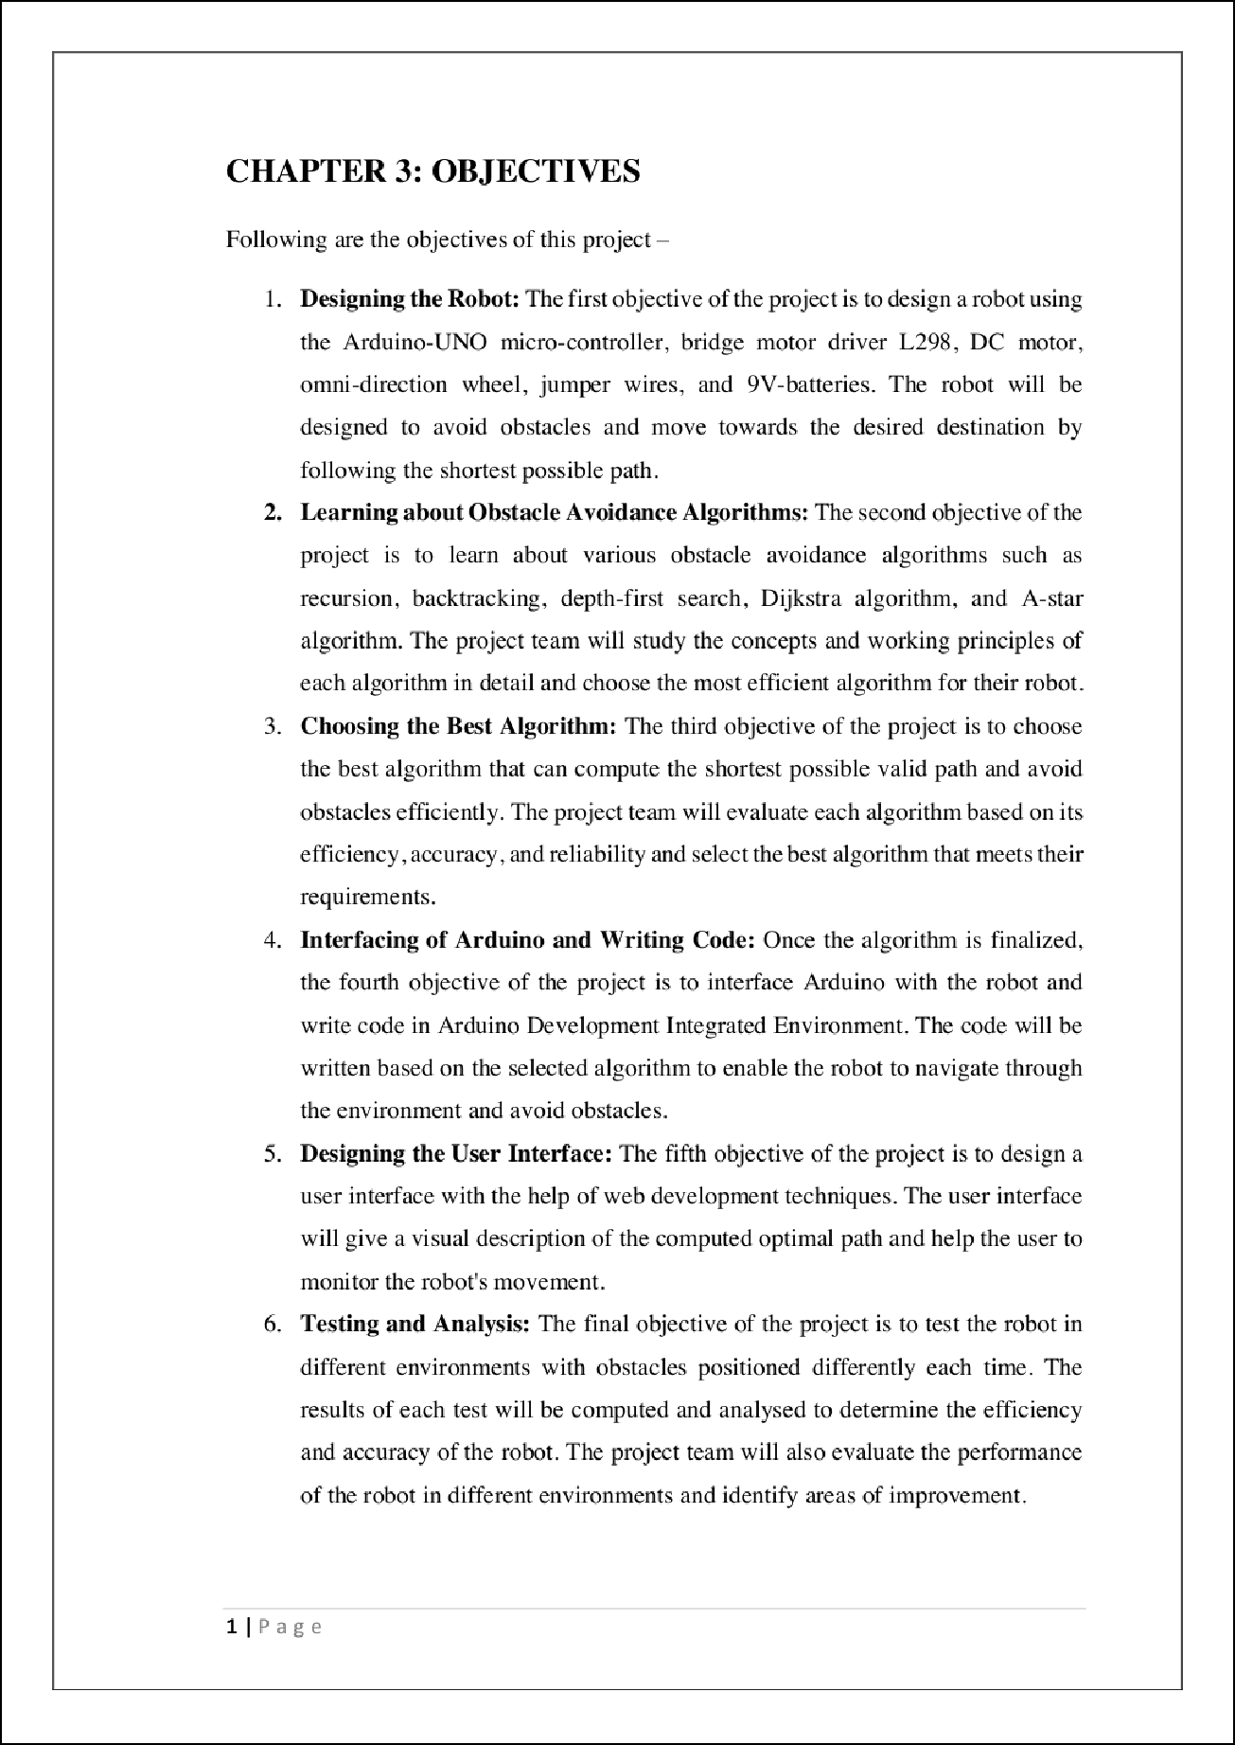

25

3

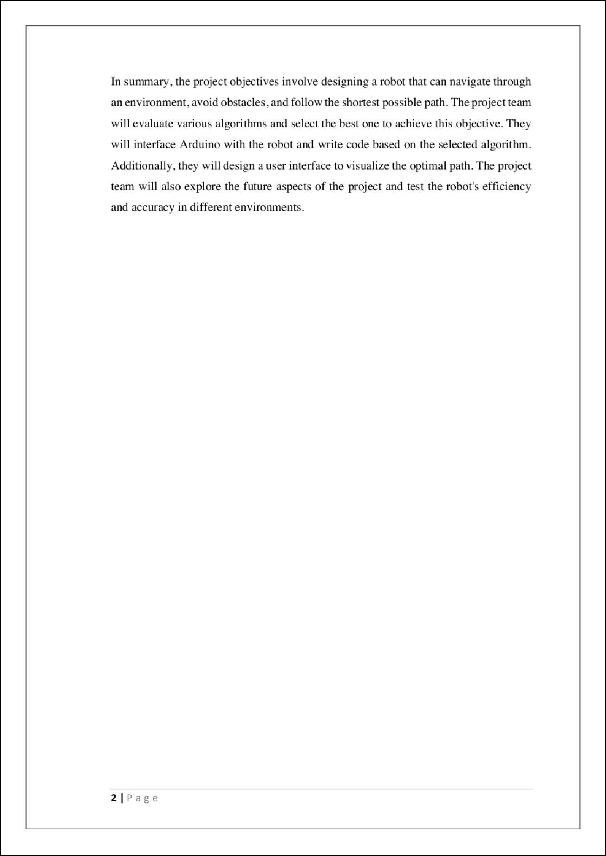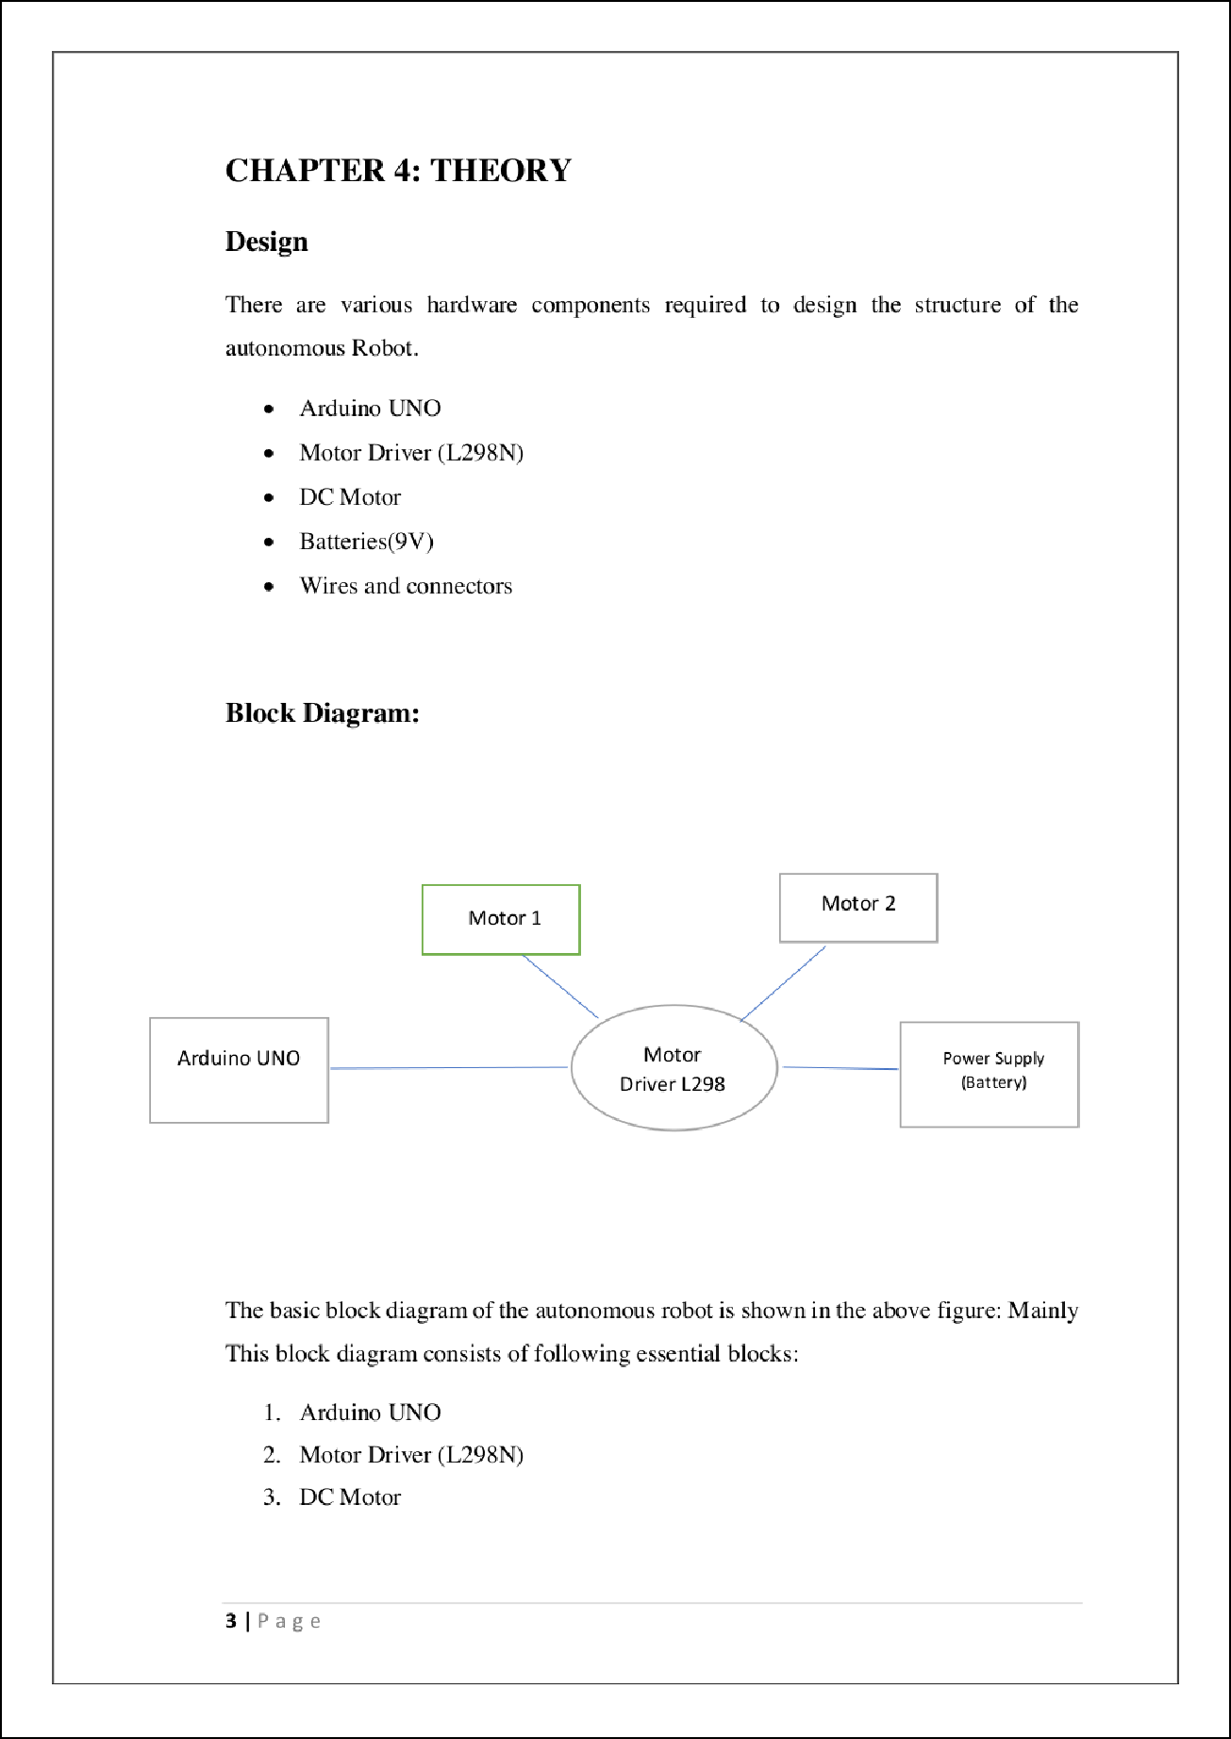

6

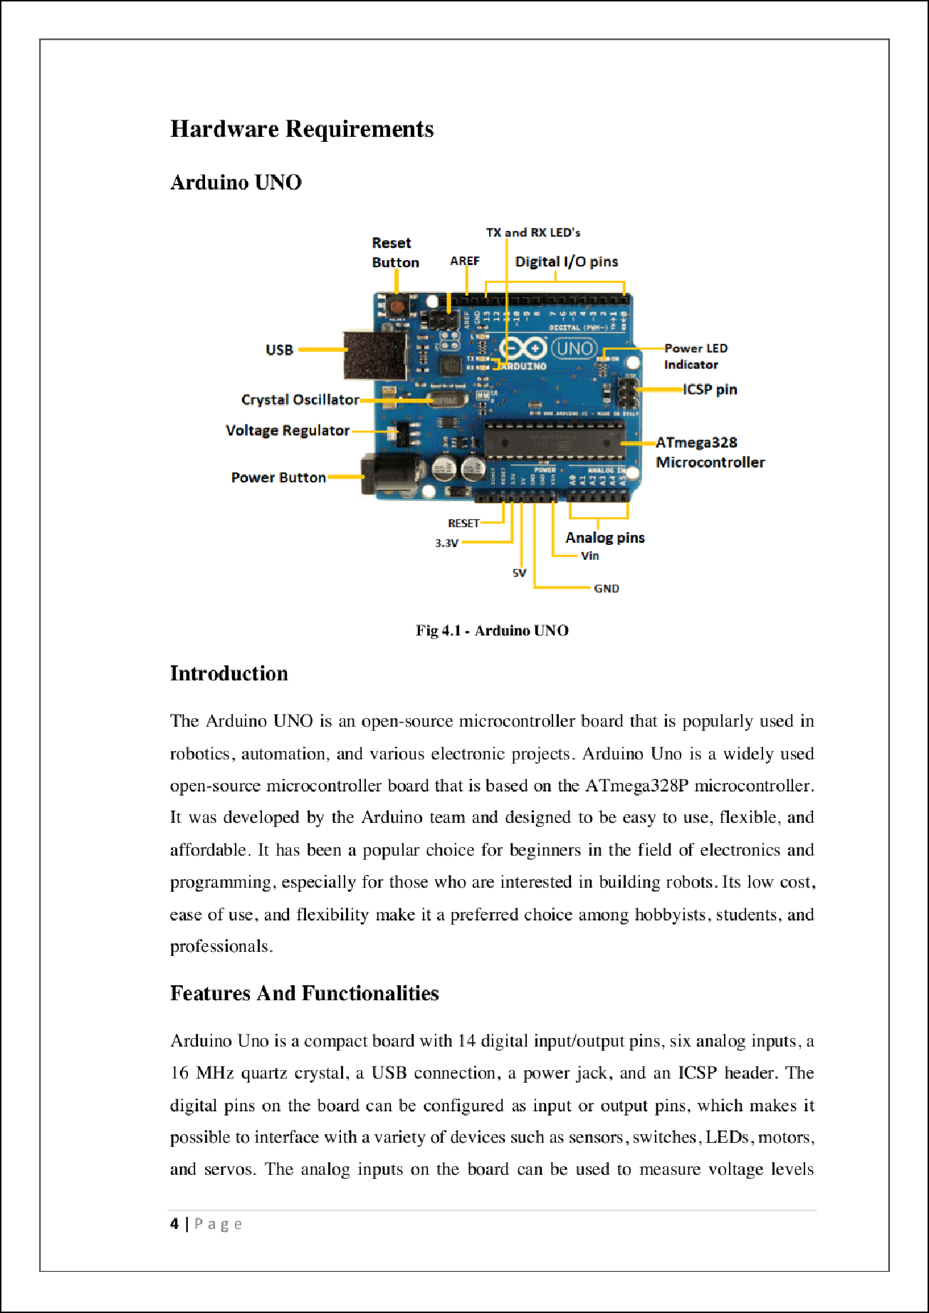

23

5

9

1

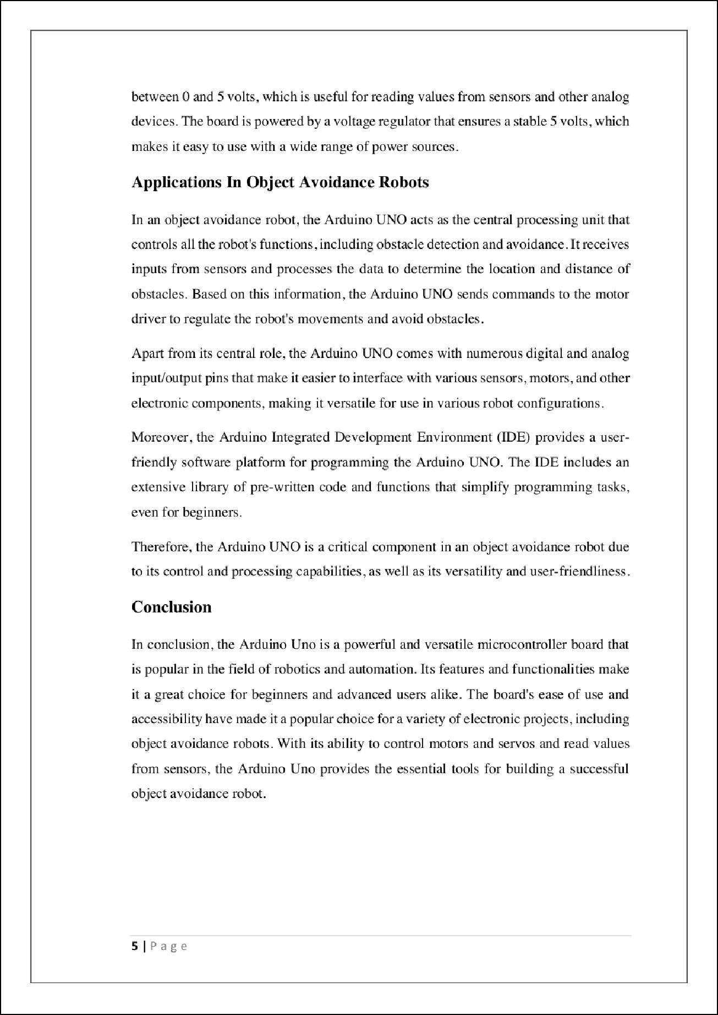

29

5

20

22

18

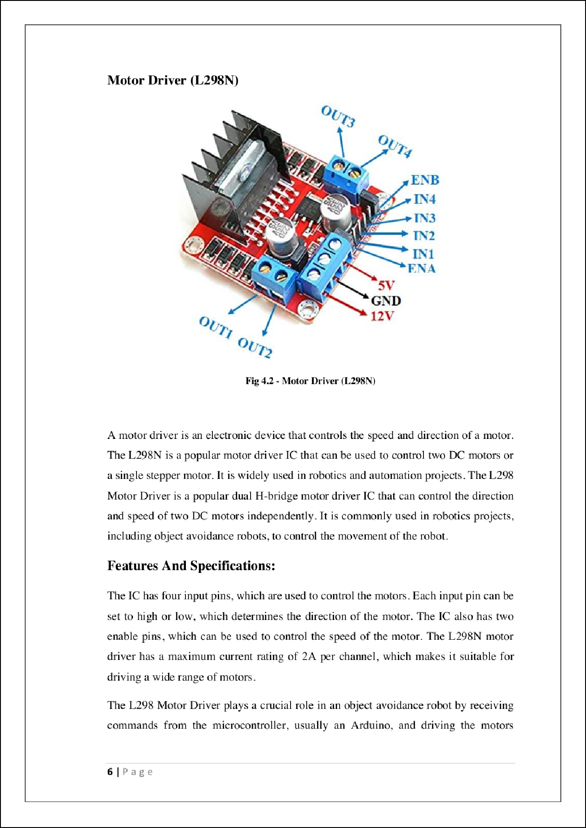

2

2

2

4

27

28

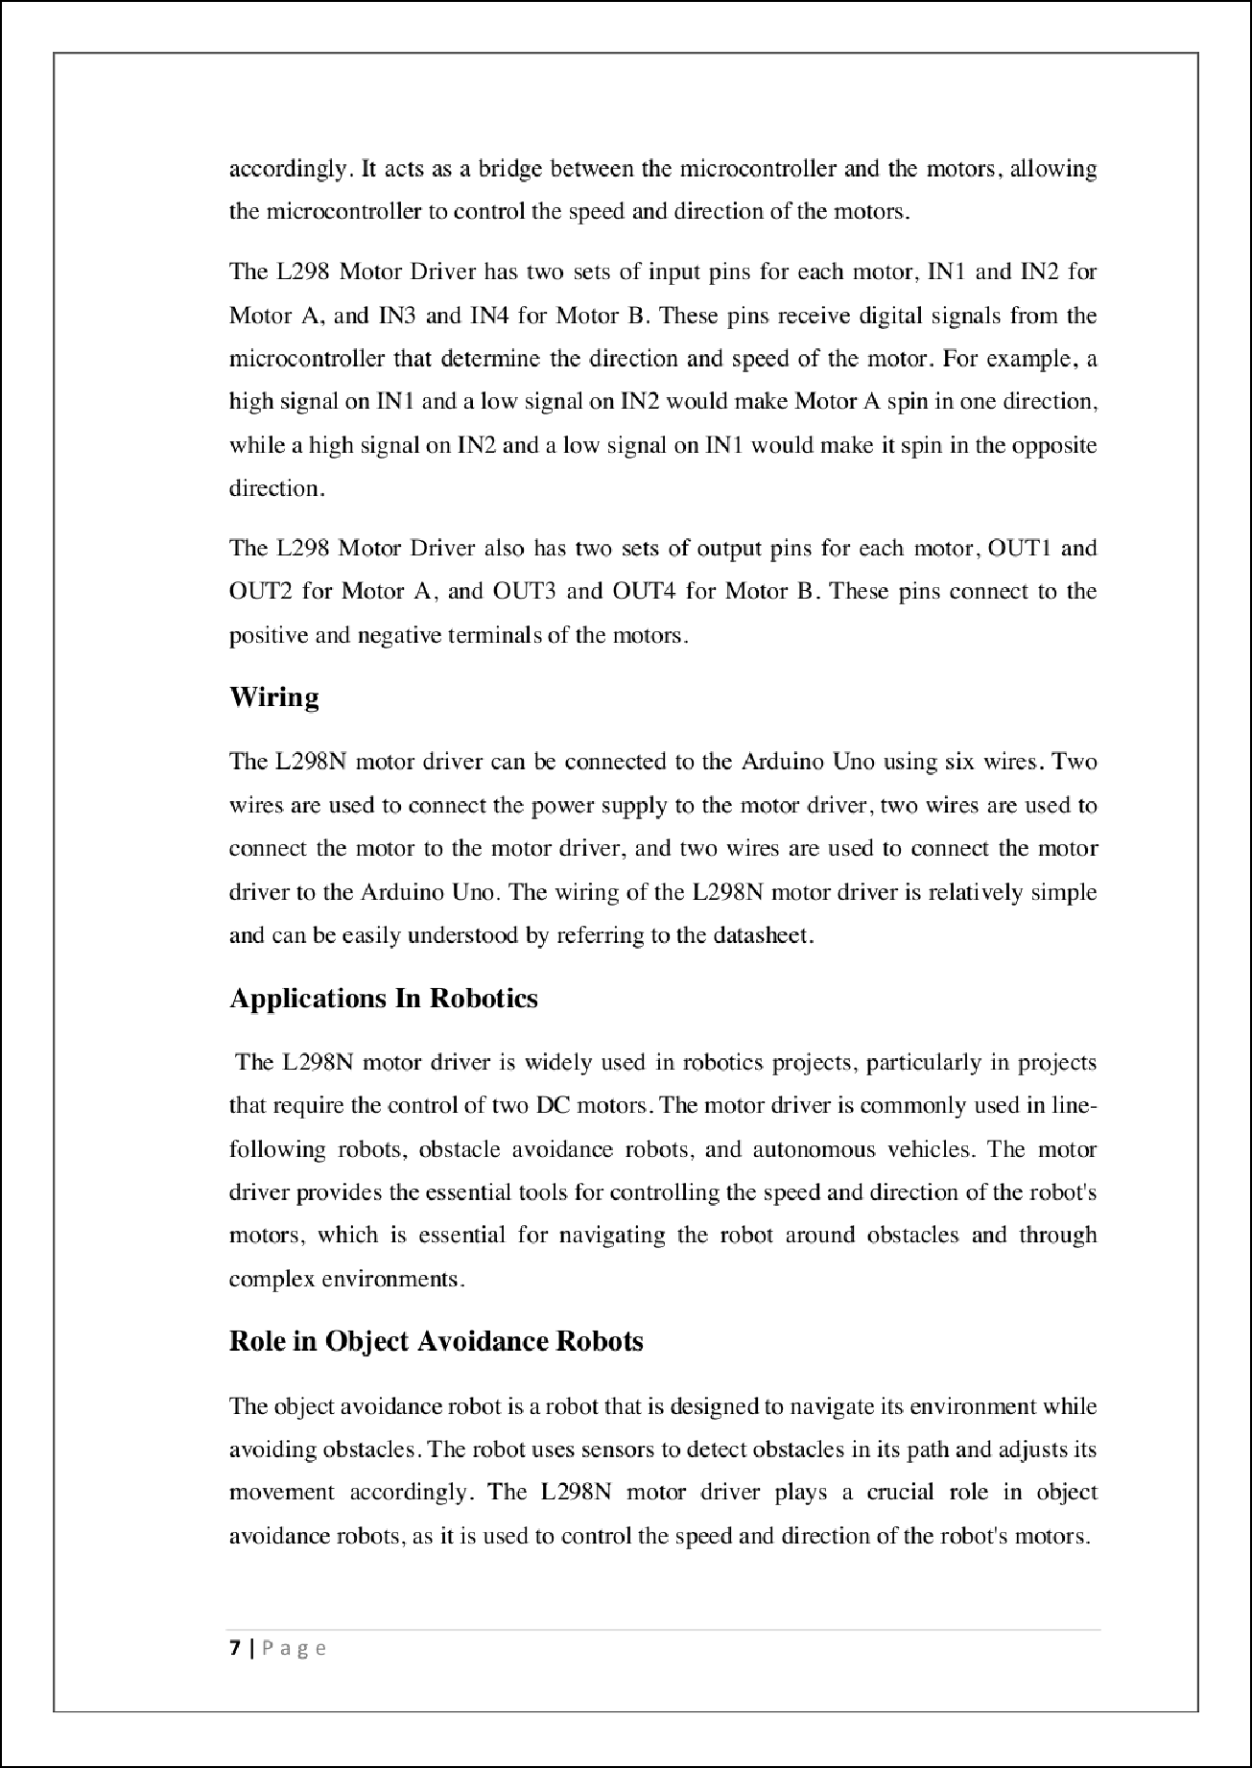

1

2

11

2

7

10 10

10

1

1

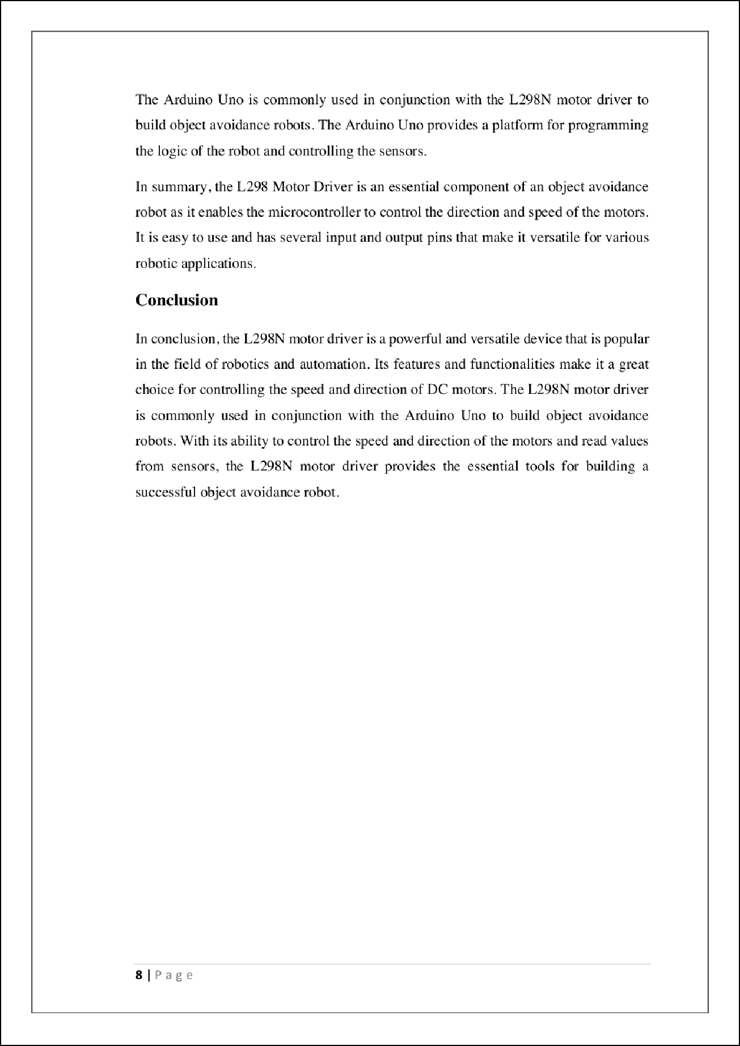

2

4

1

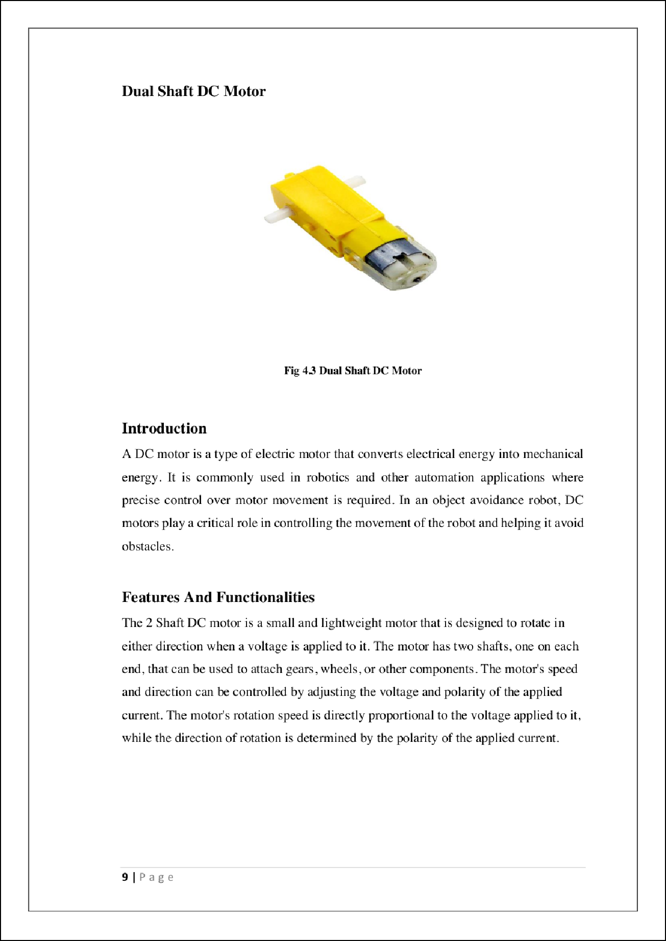

16

24

7

30

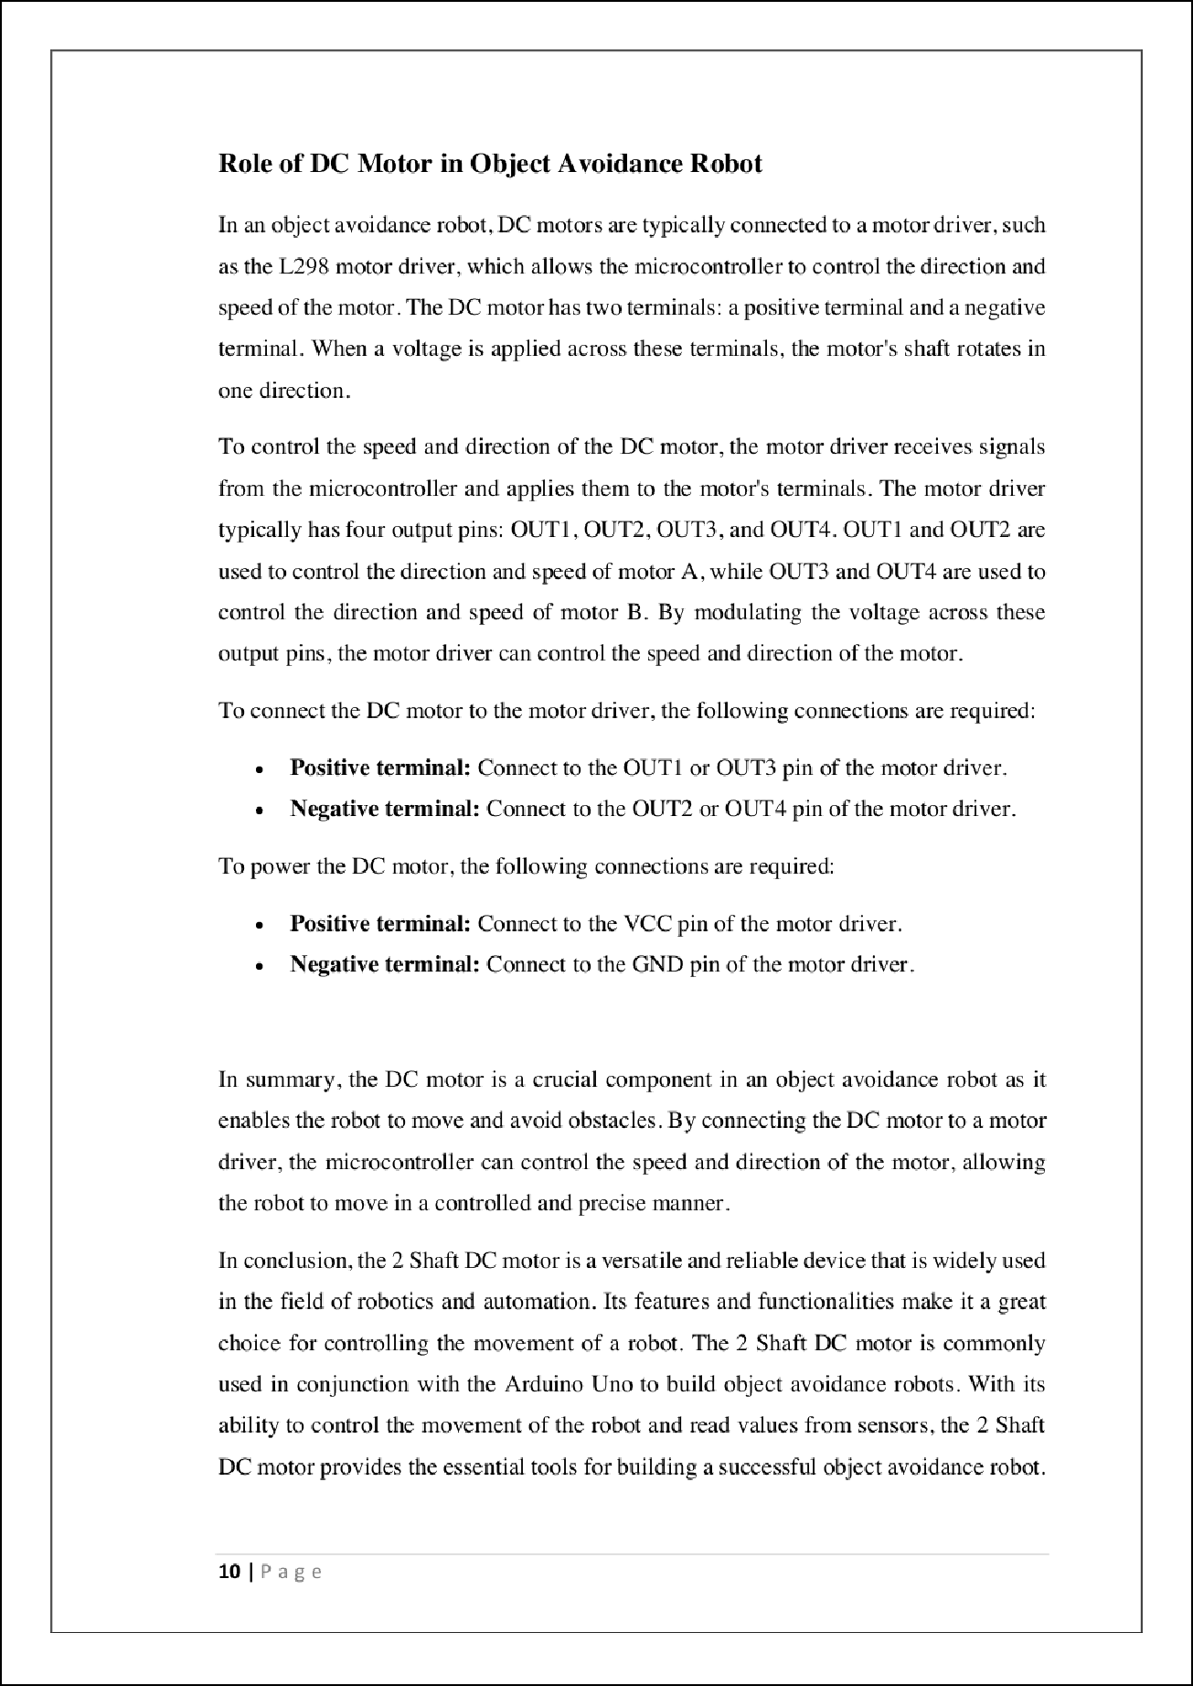

2

21

1

4

5

8

8

8

8

1

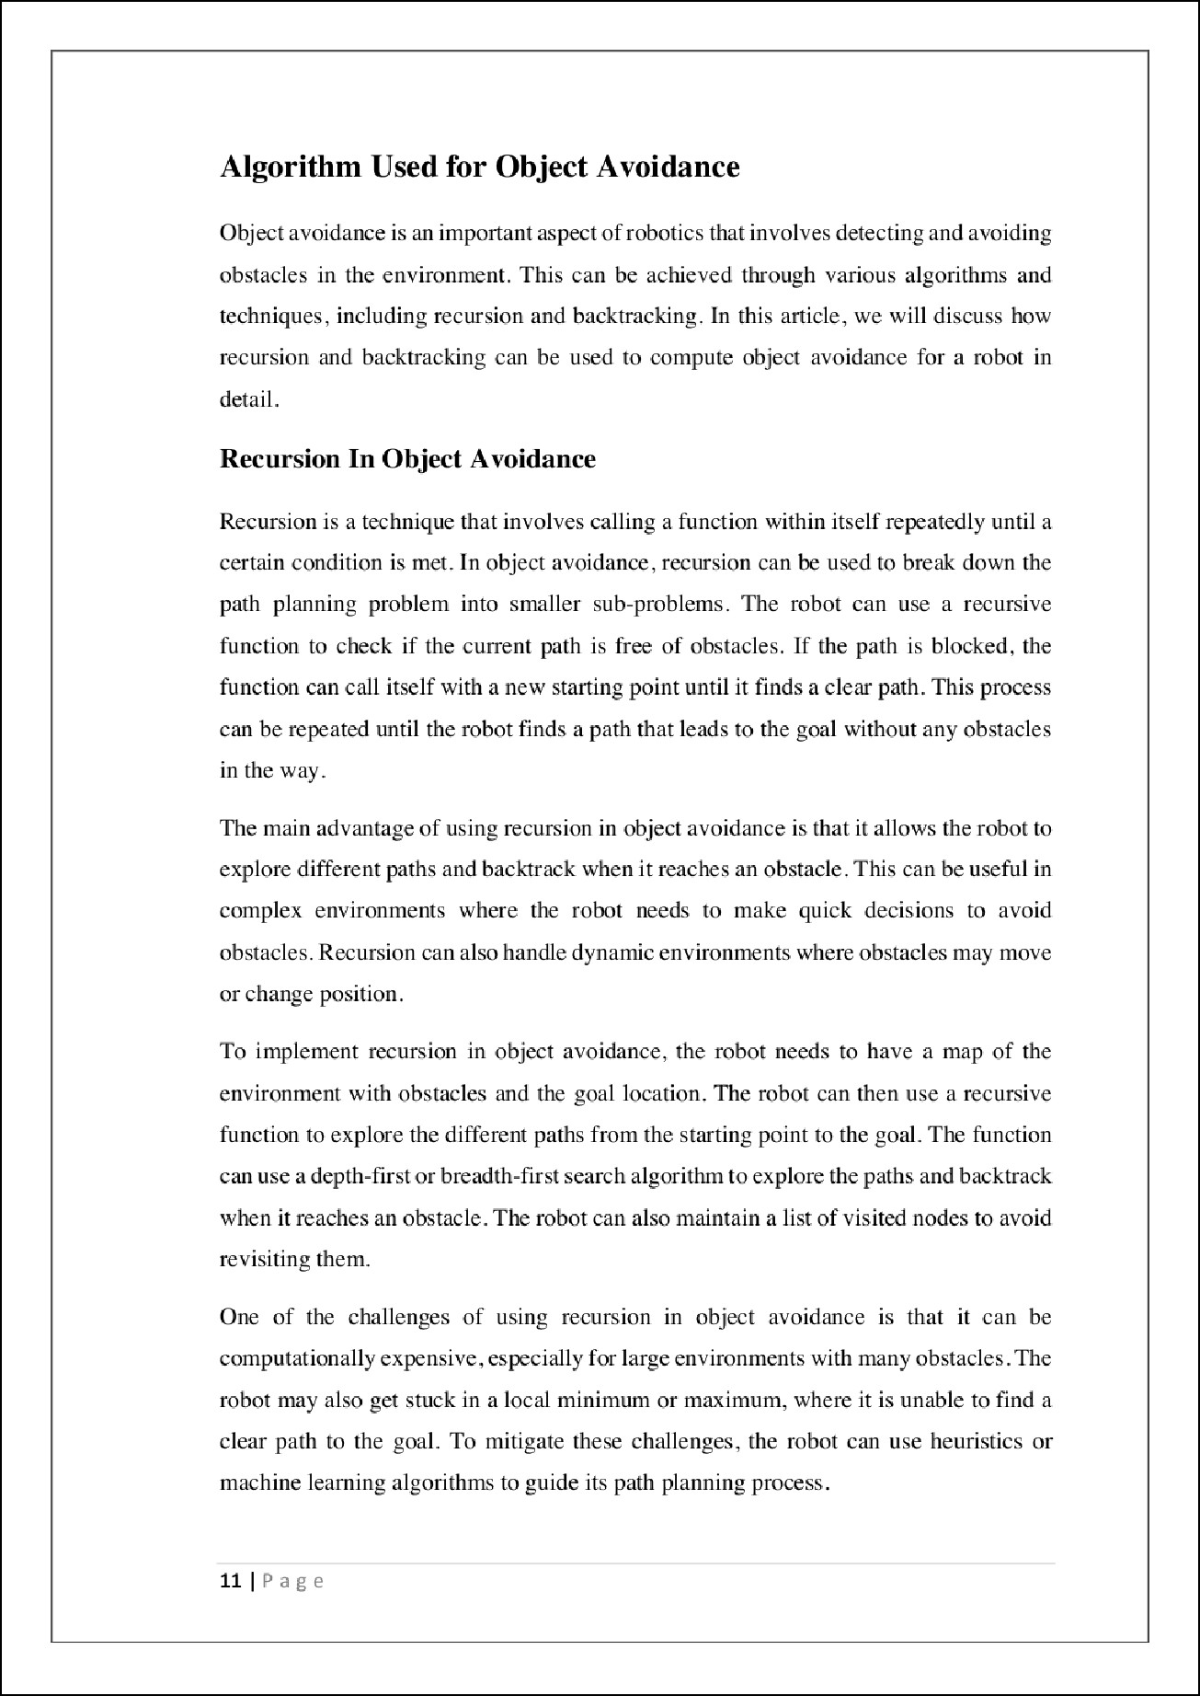

15

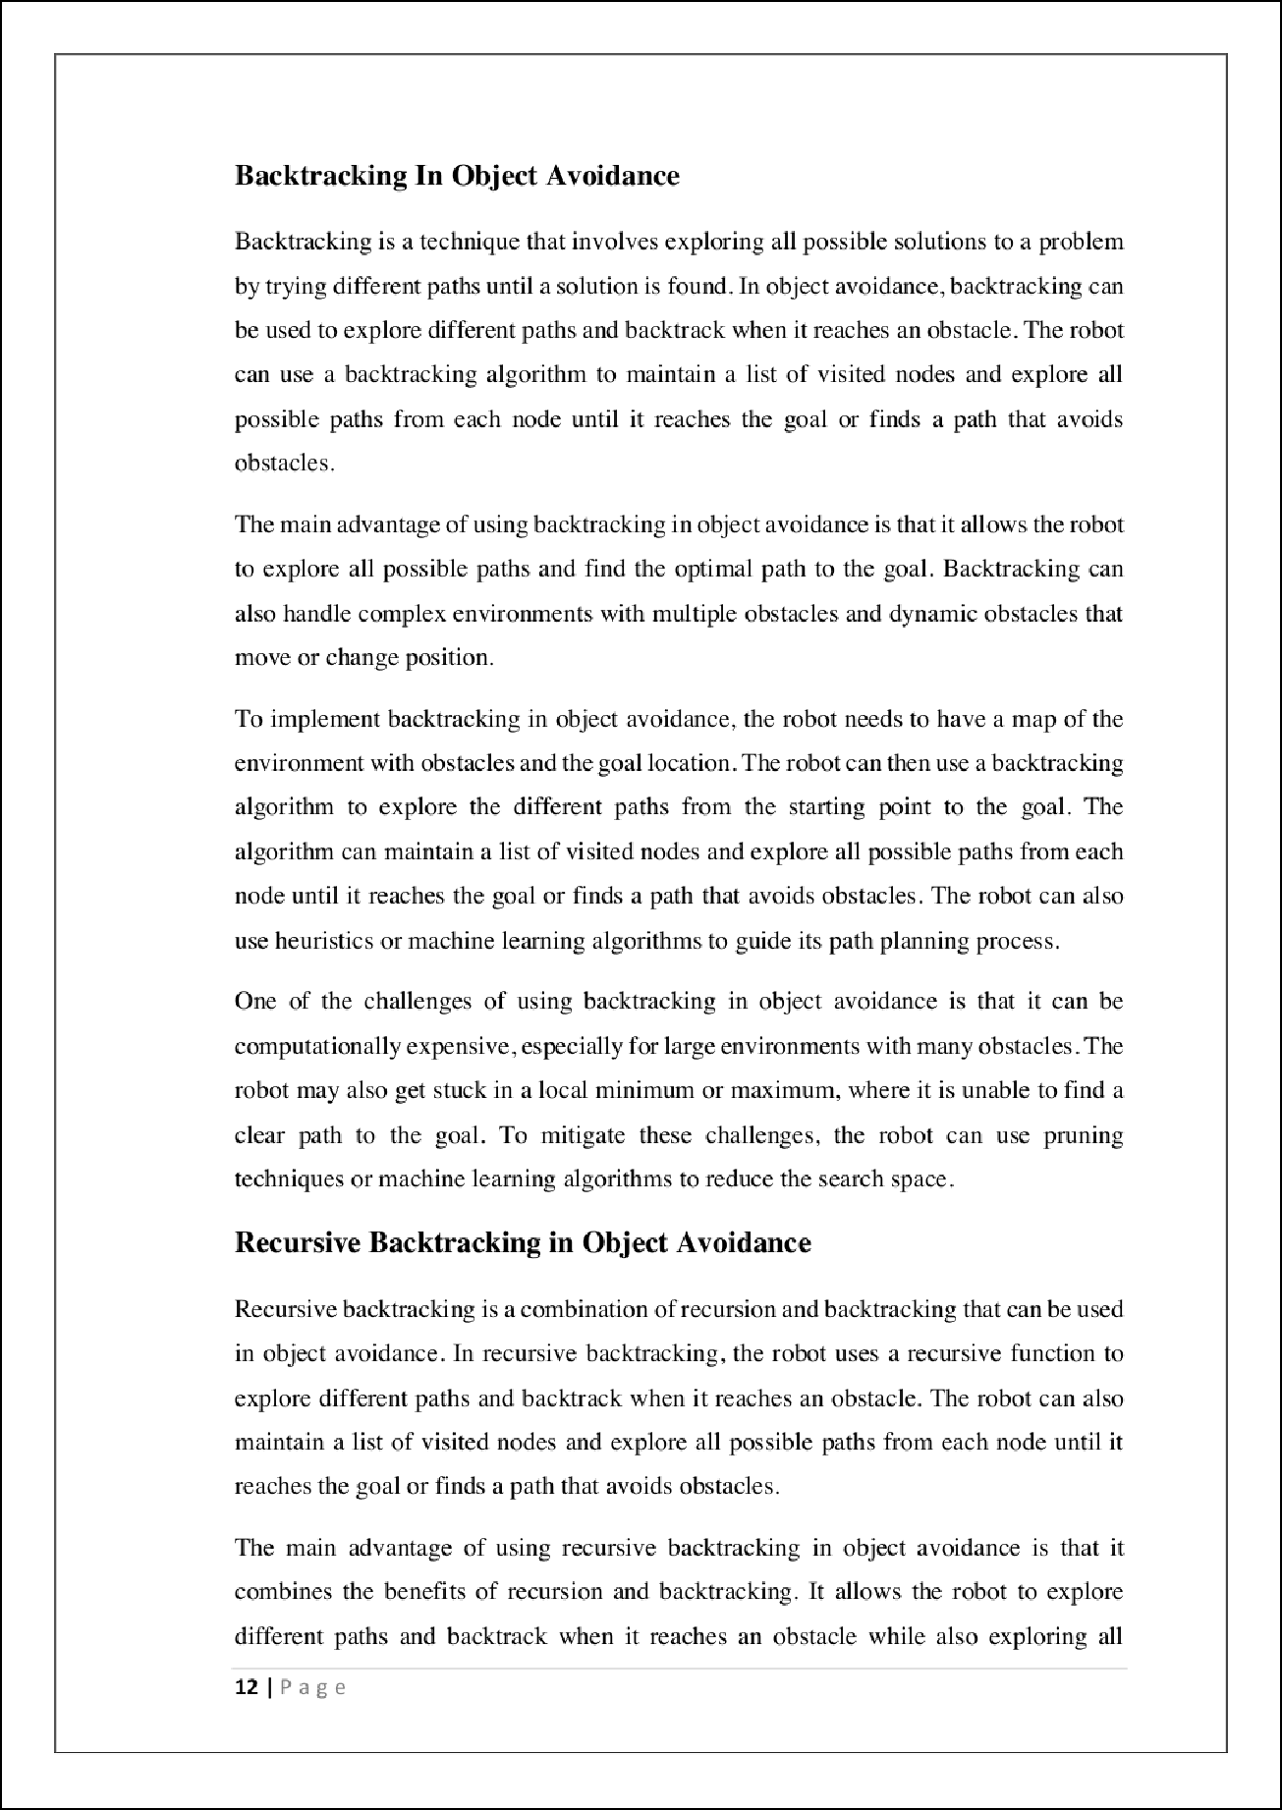

12

15

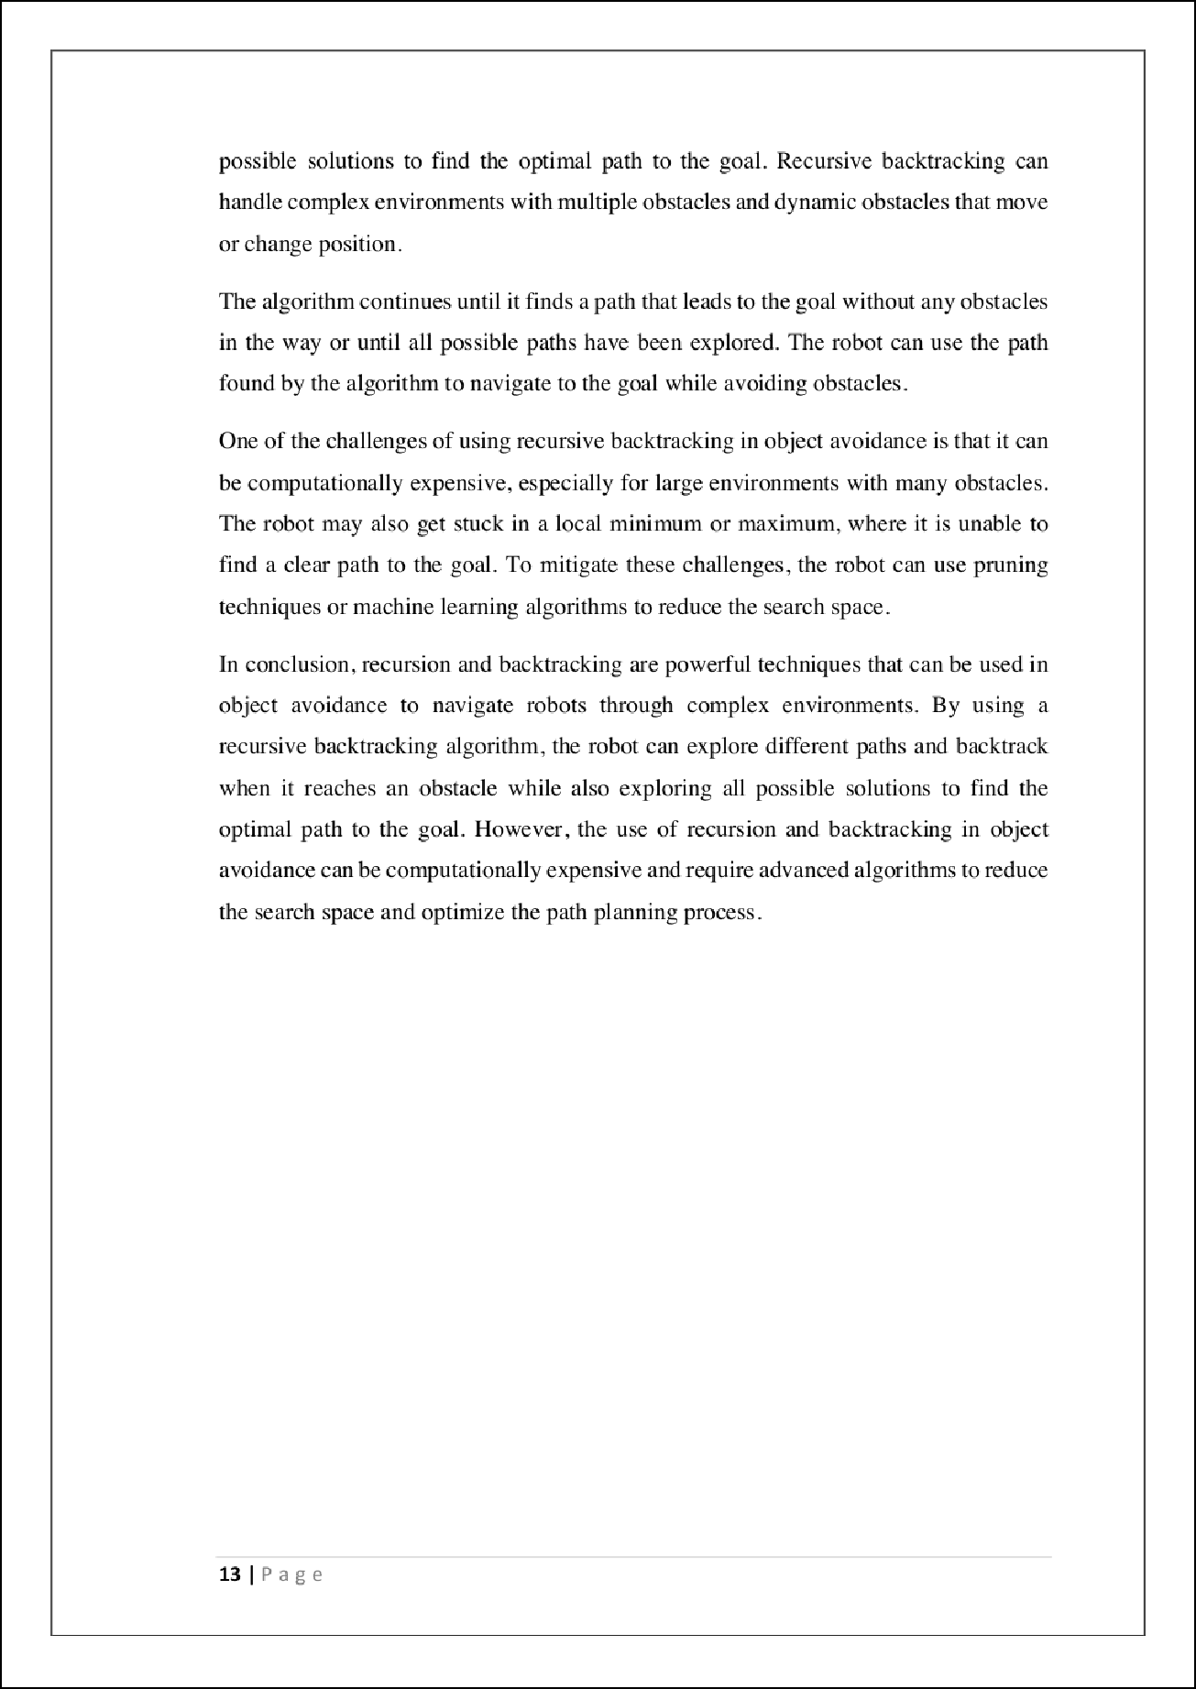

12

12

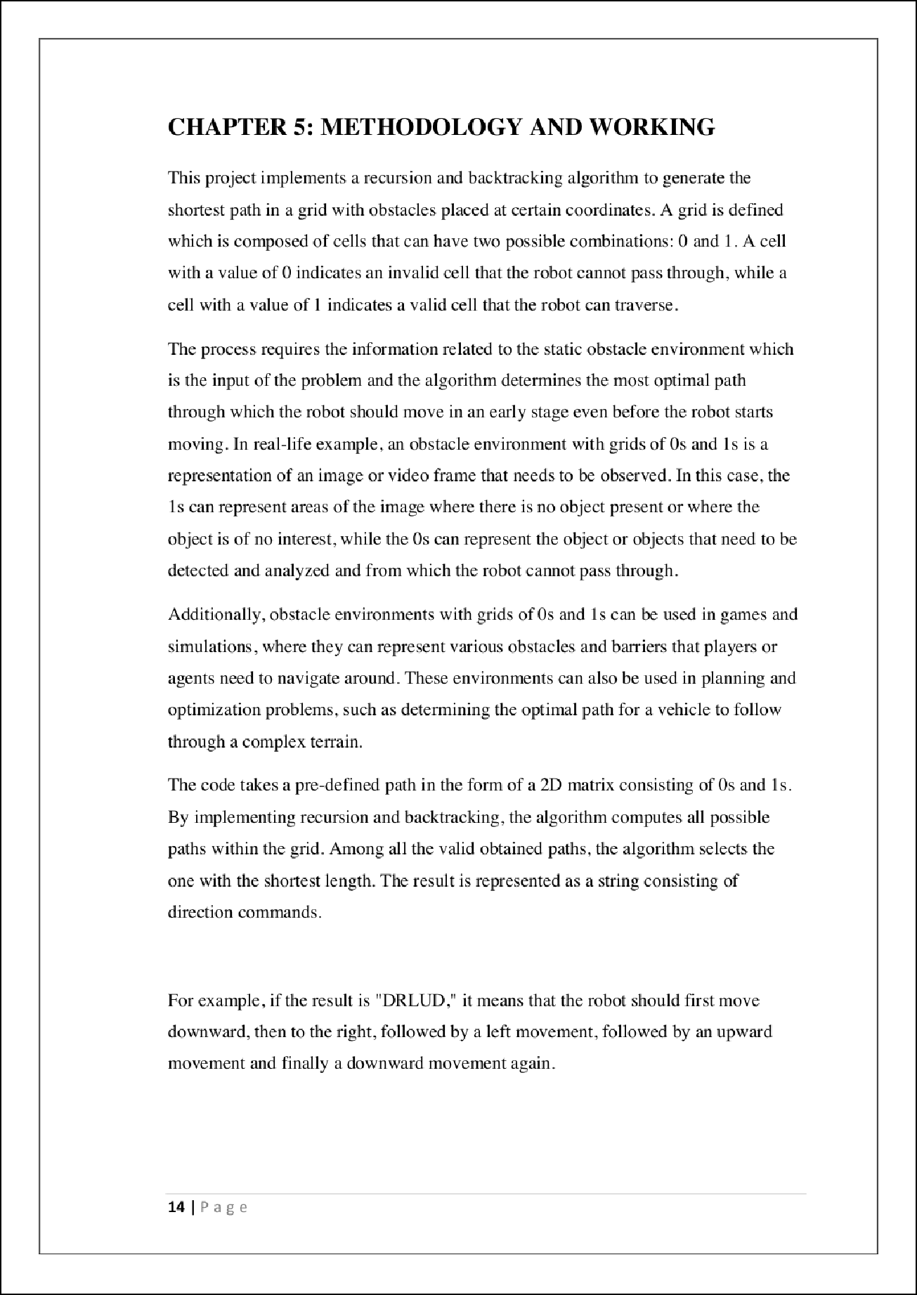

17

17

13

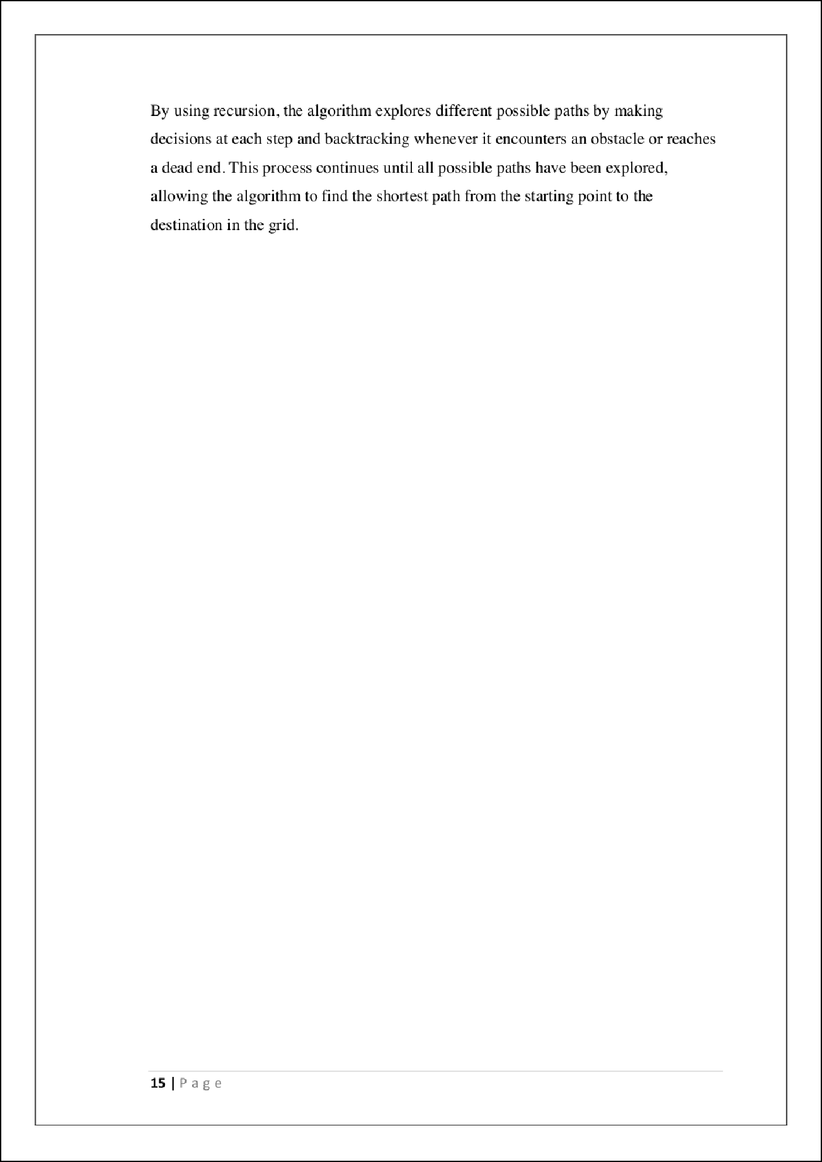

13

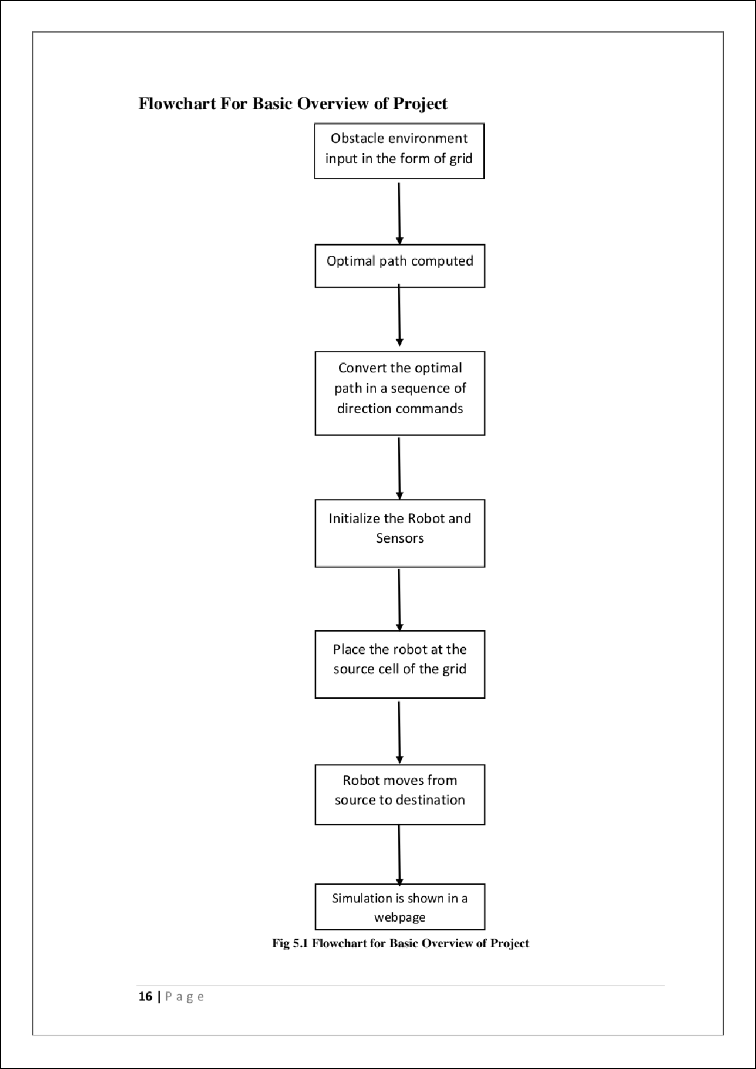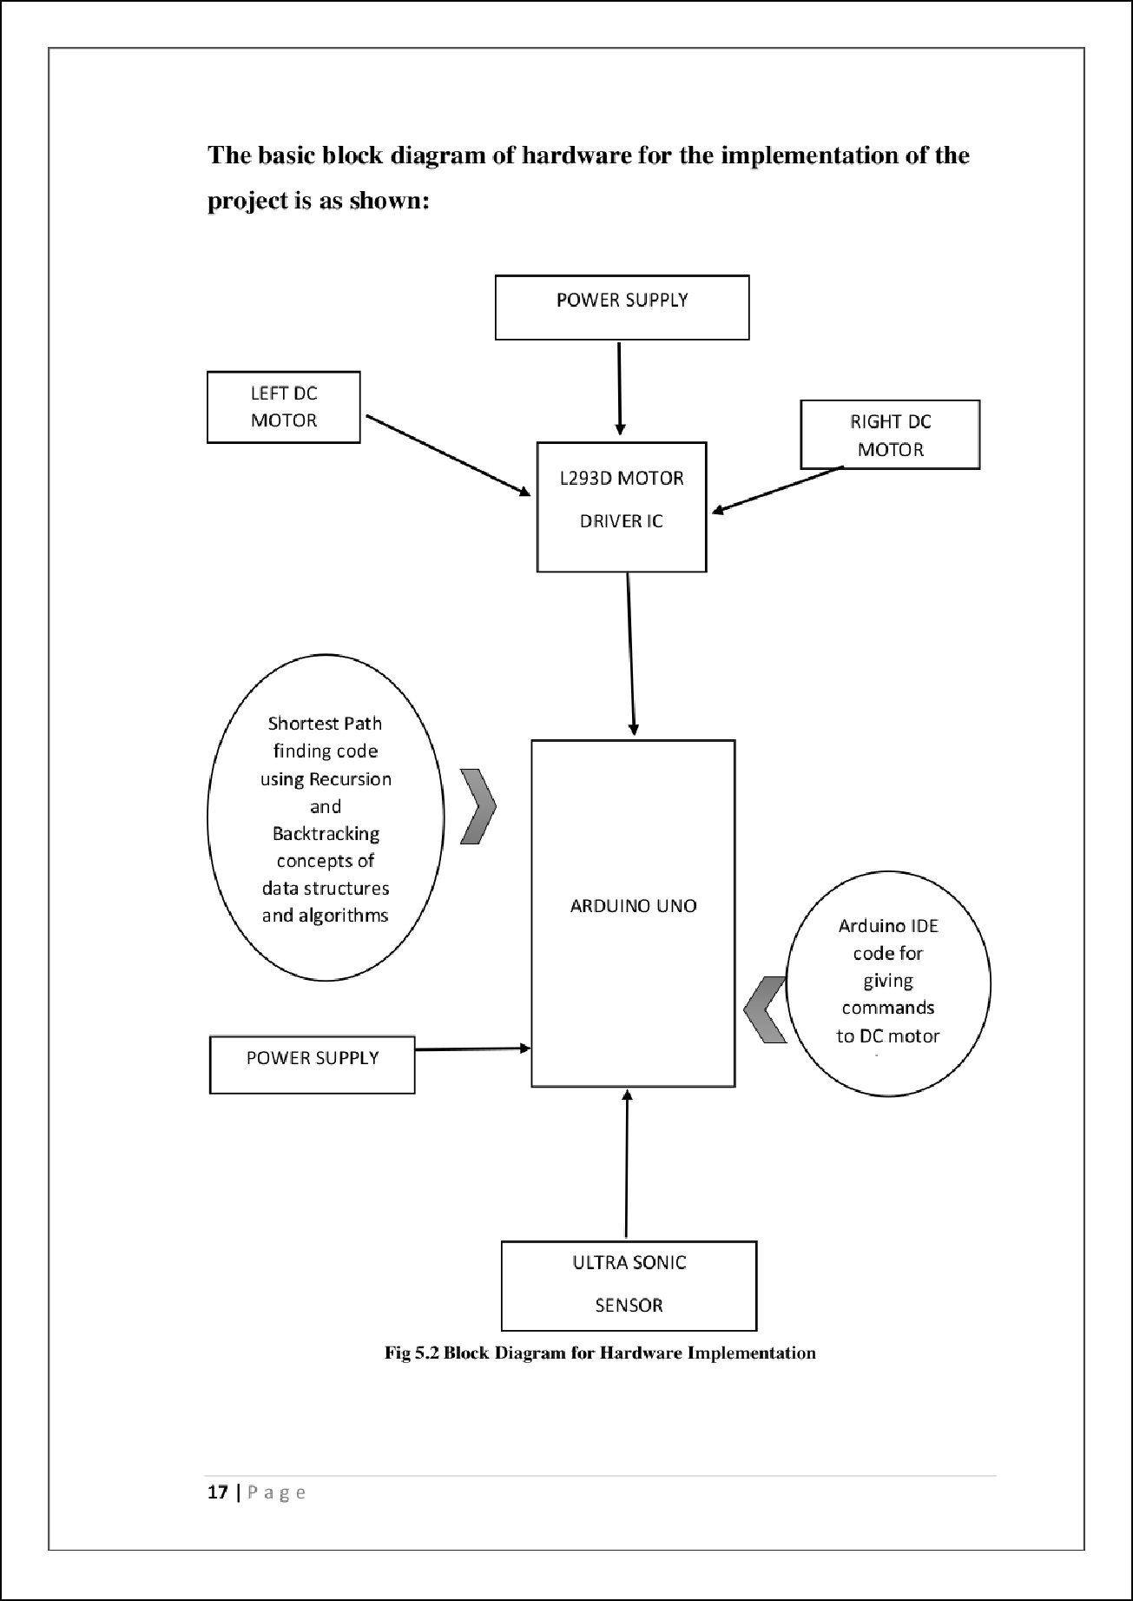

7

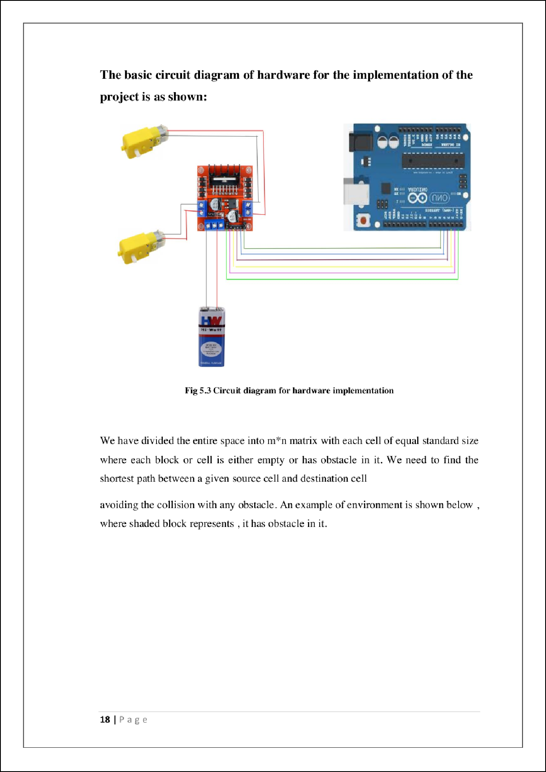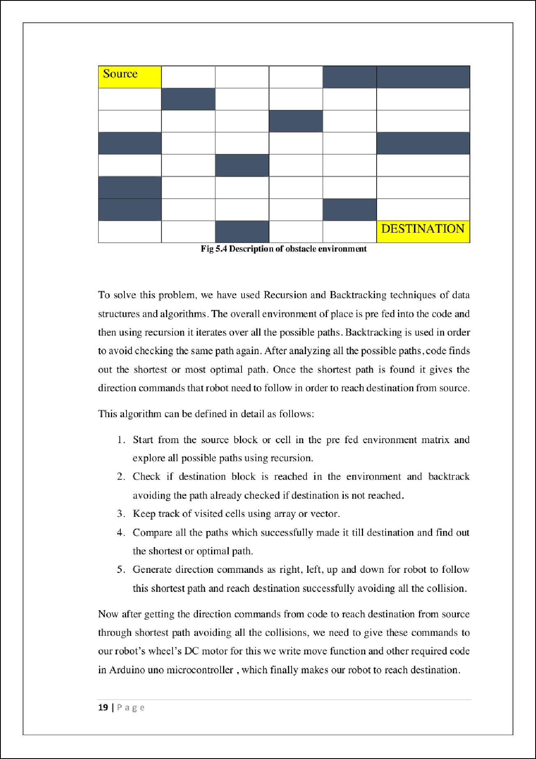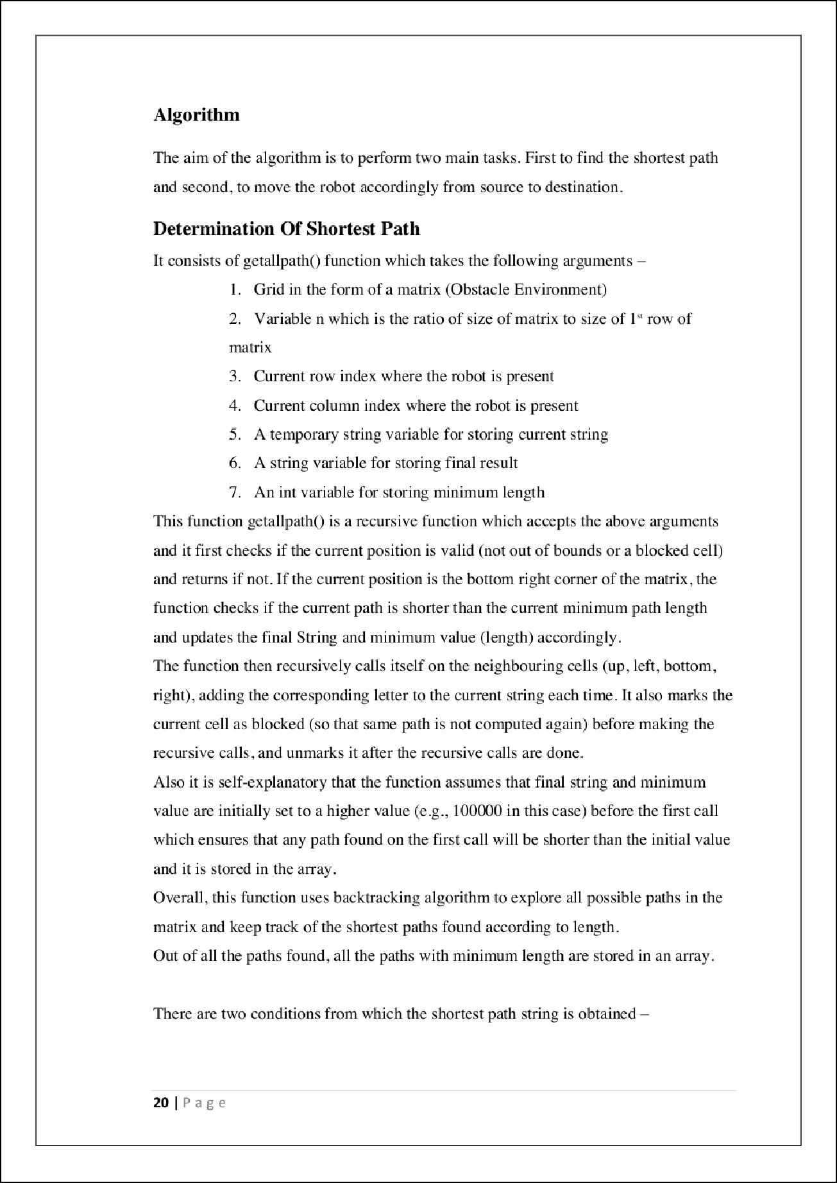

19

19

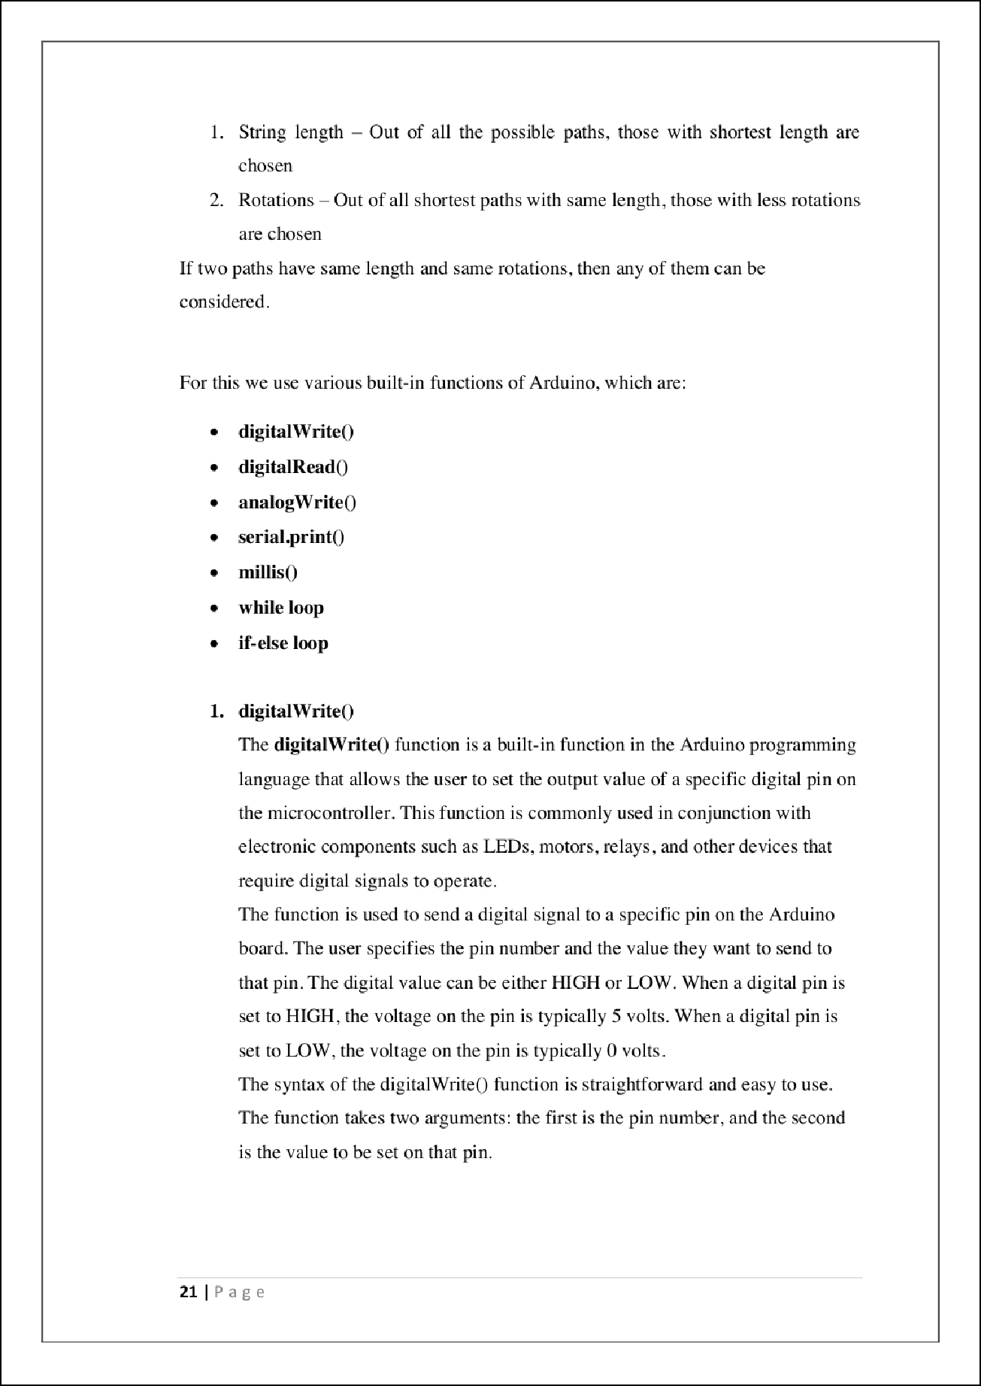

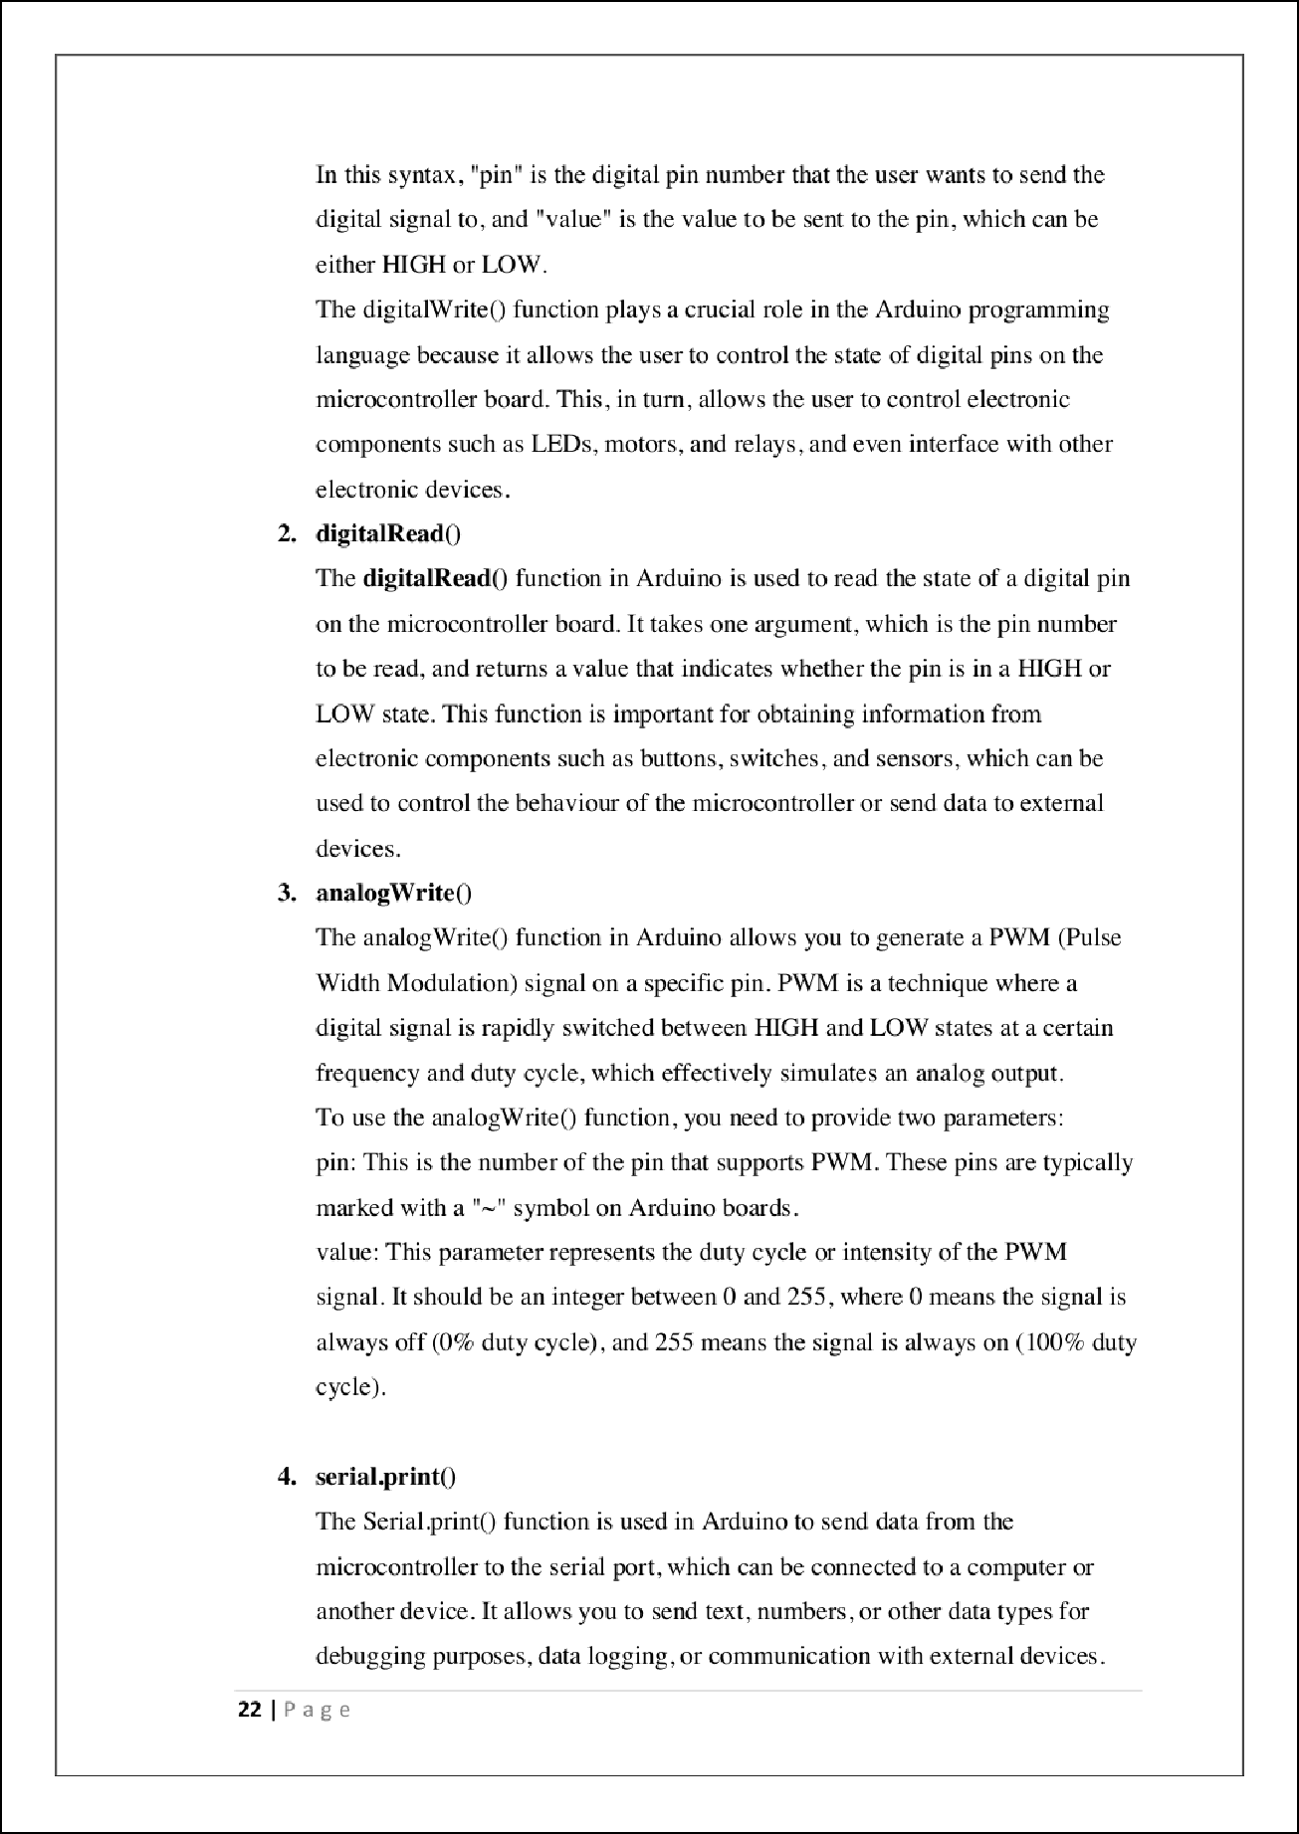

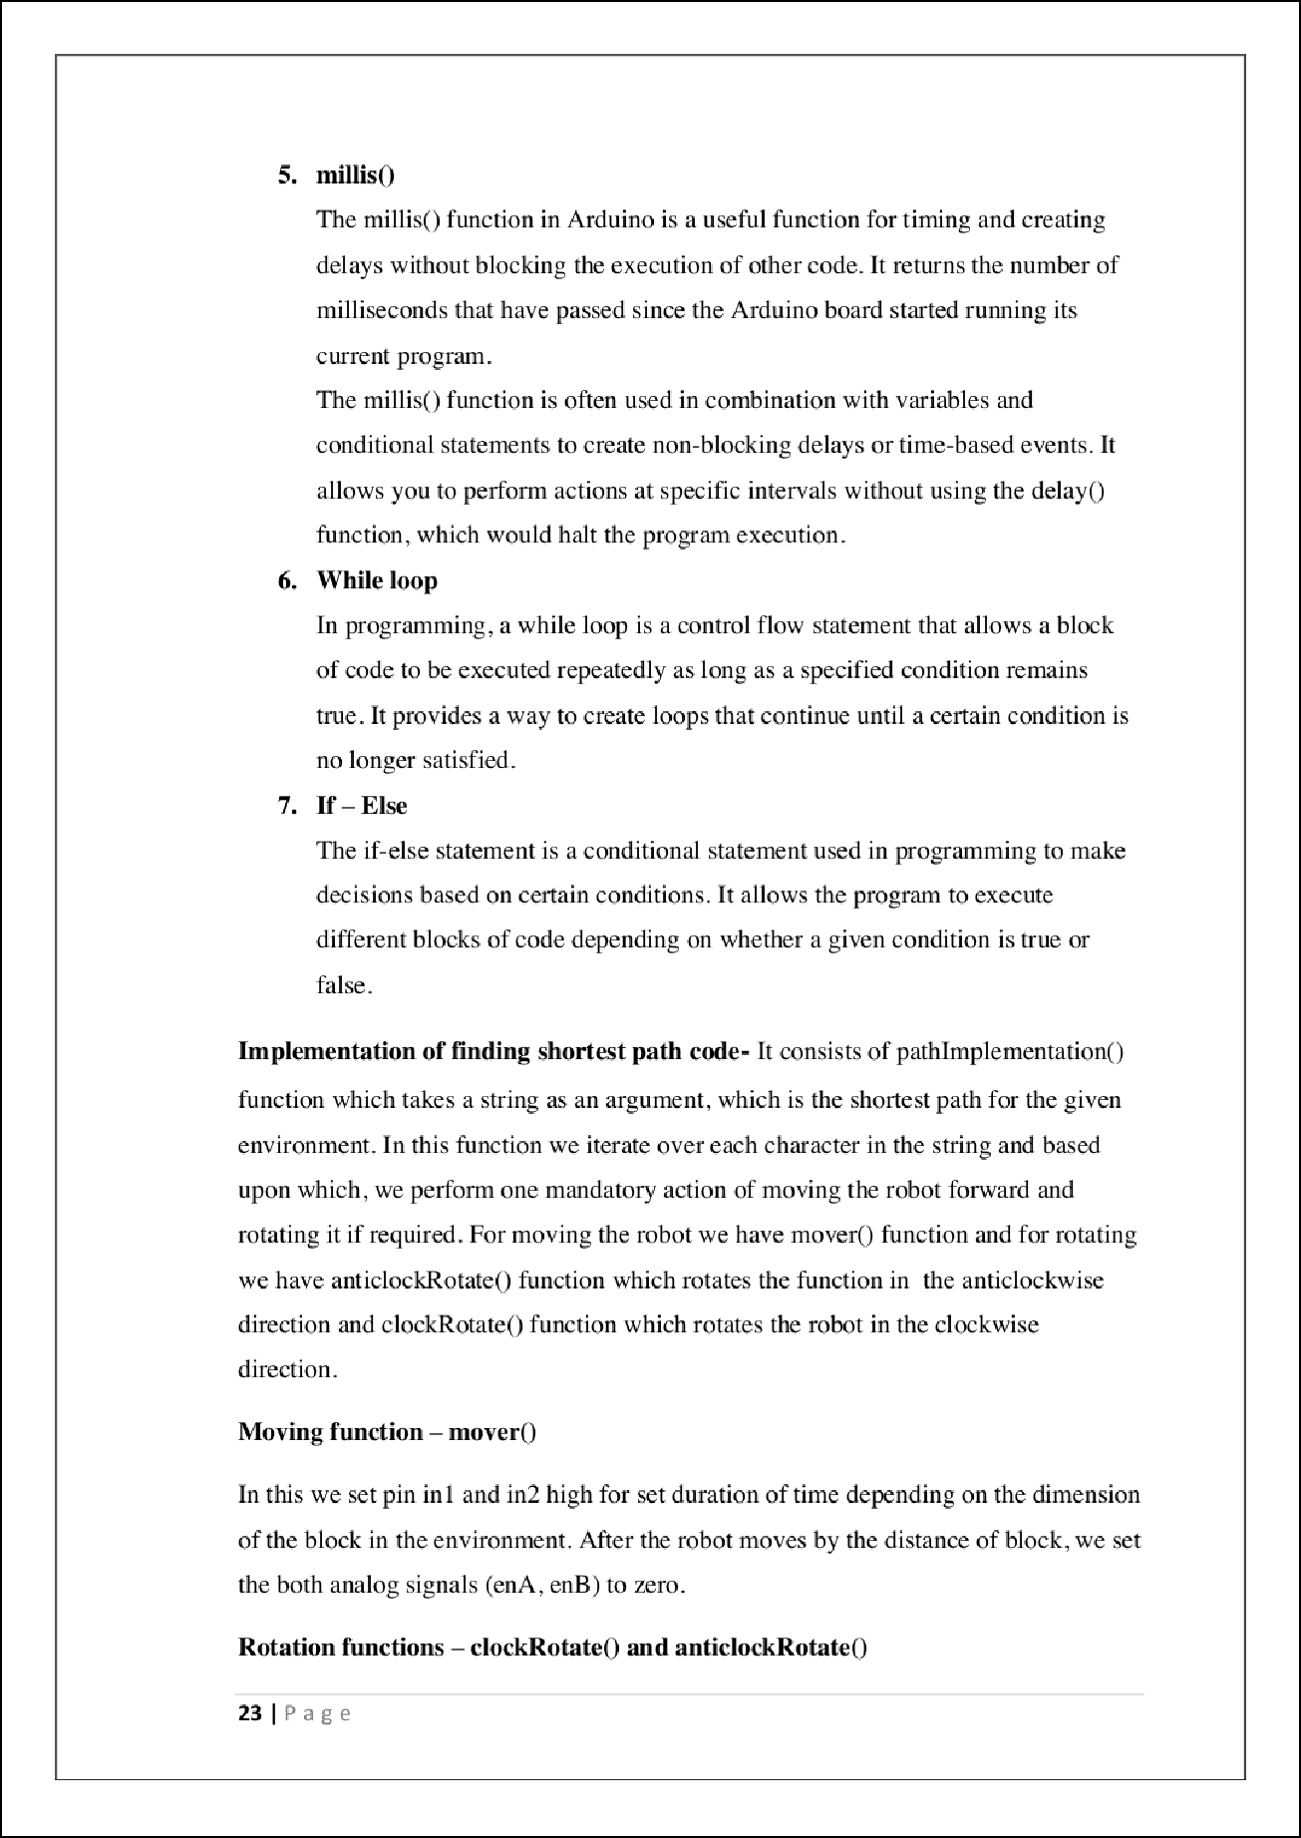

14

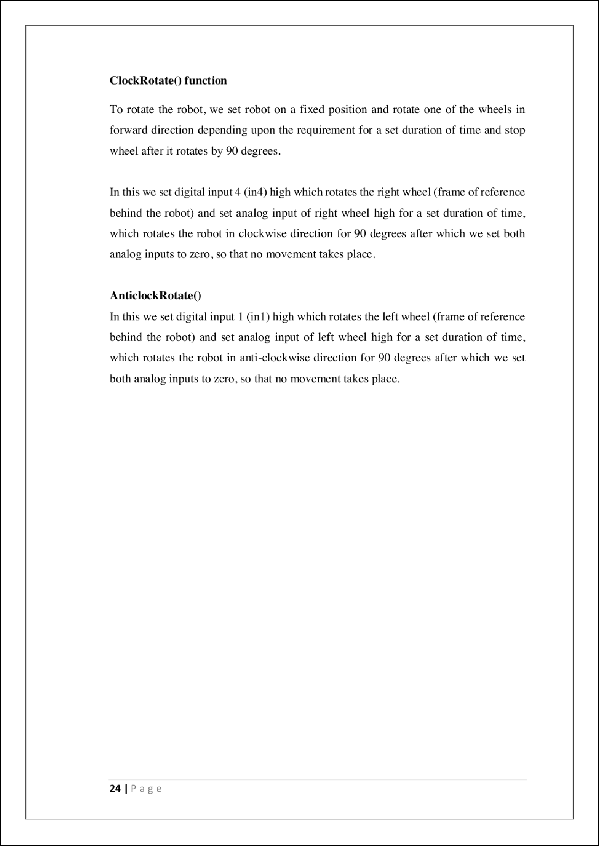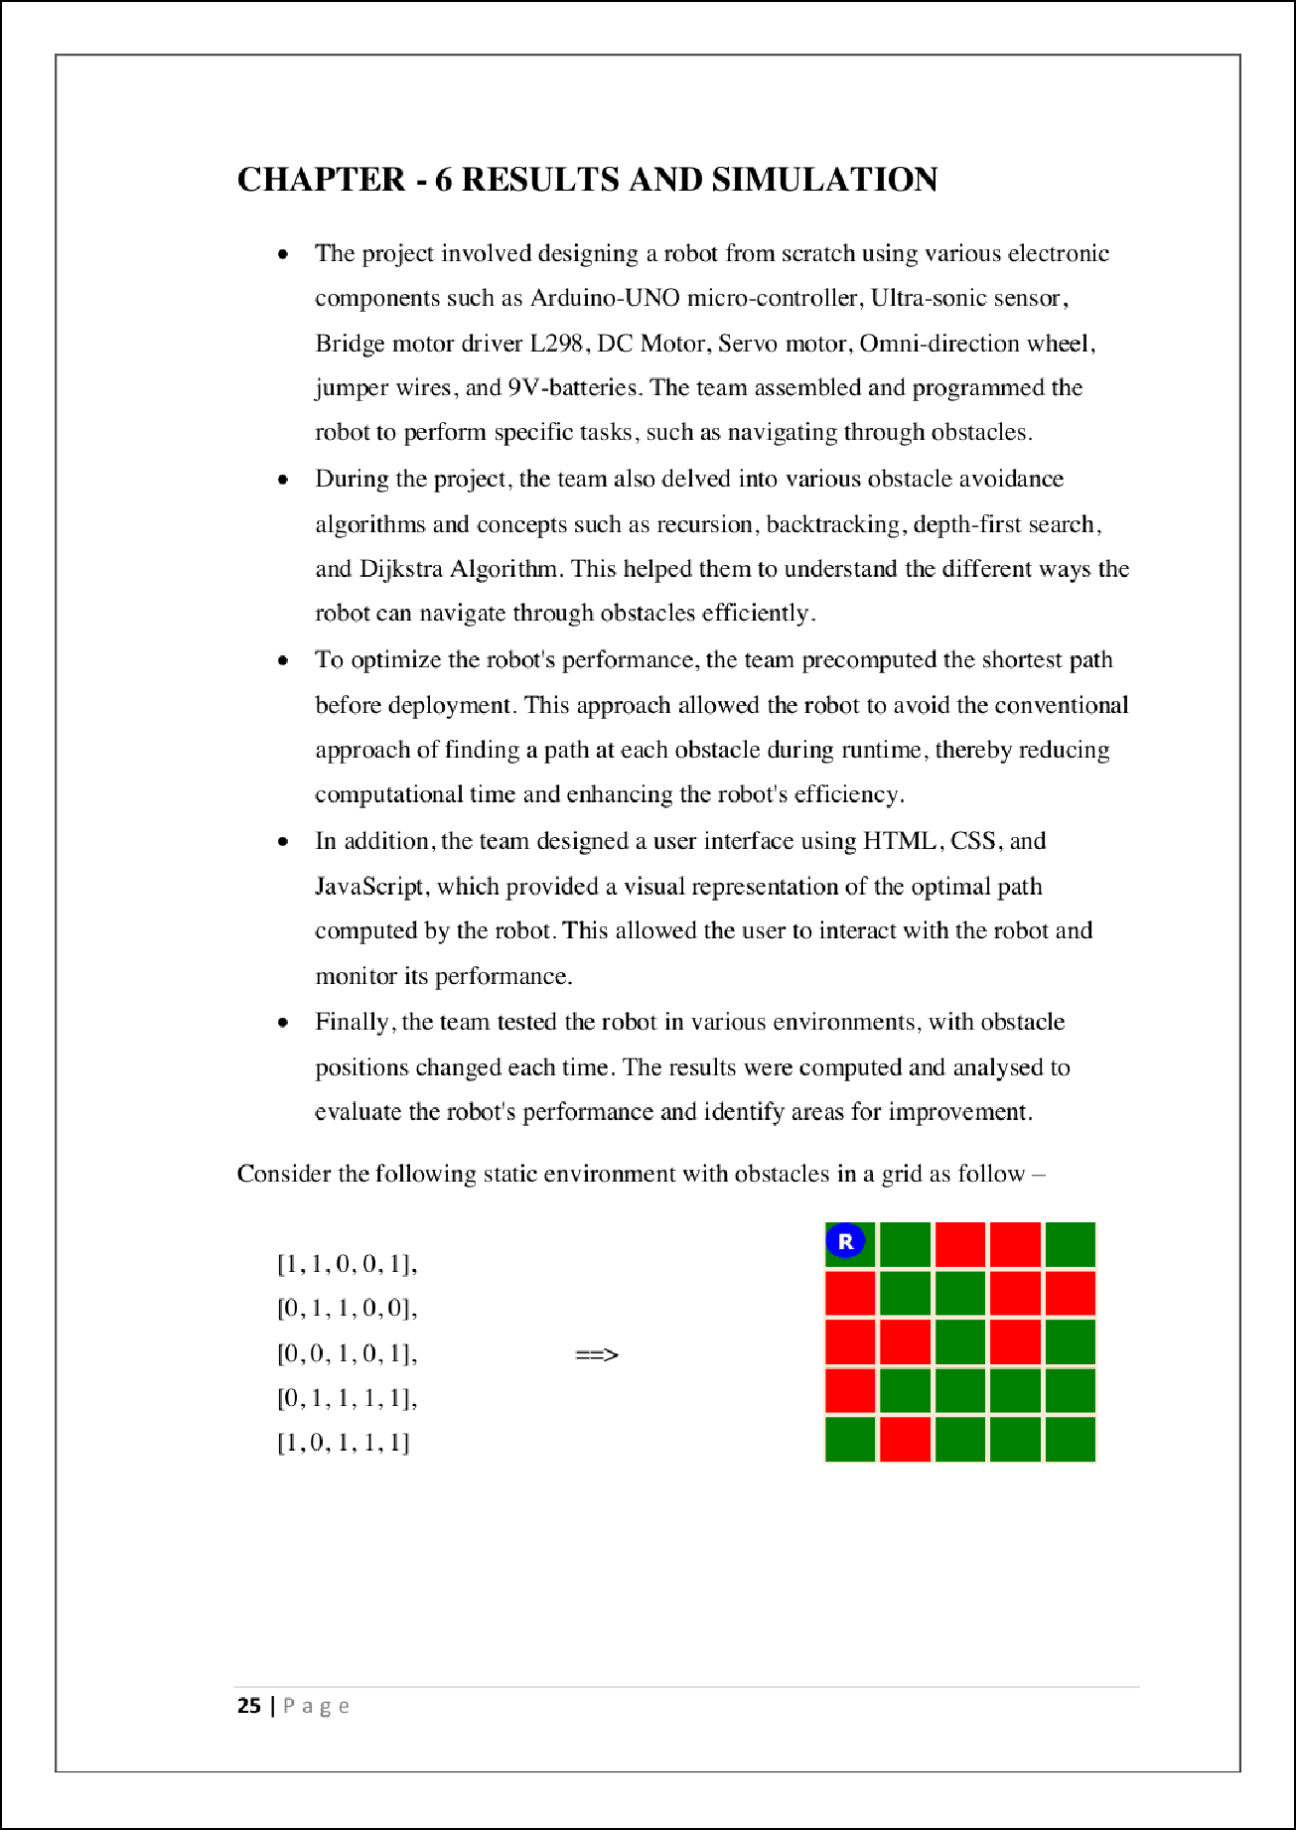

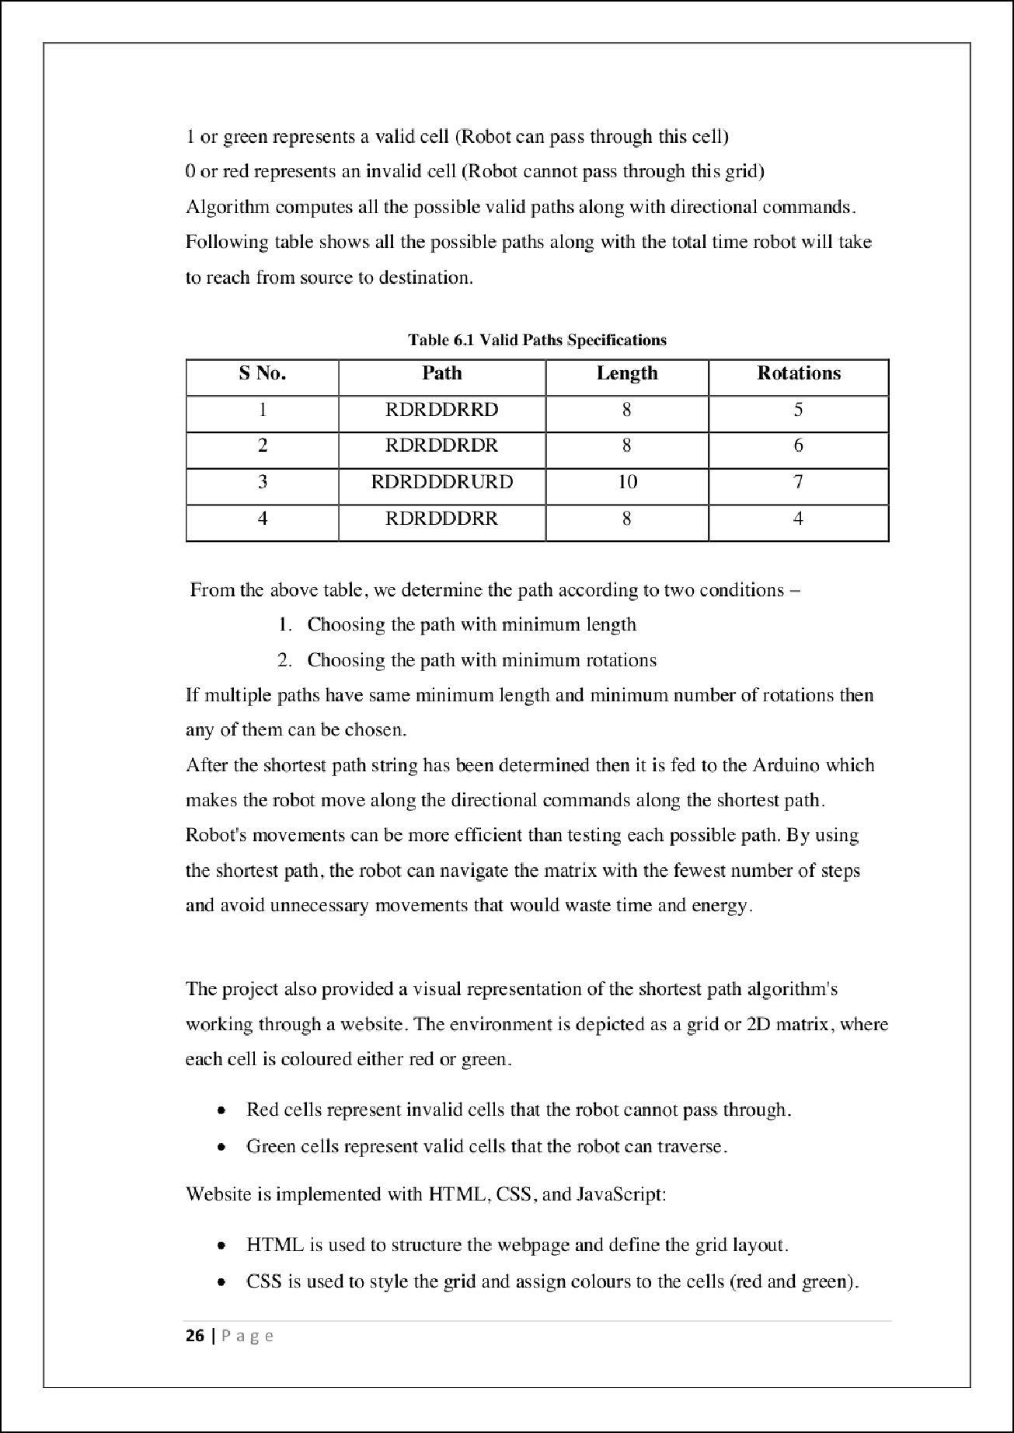

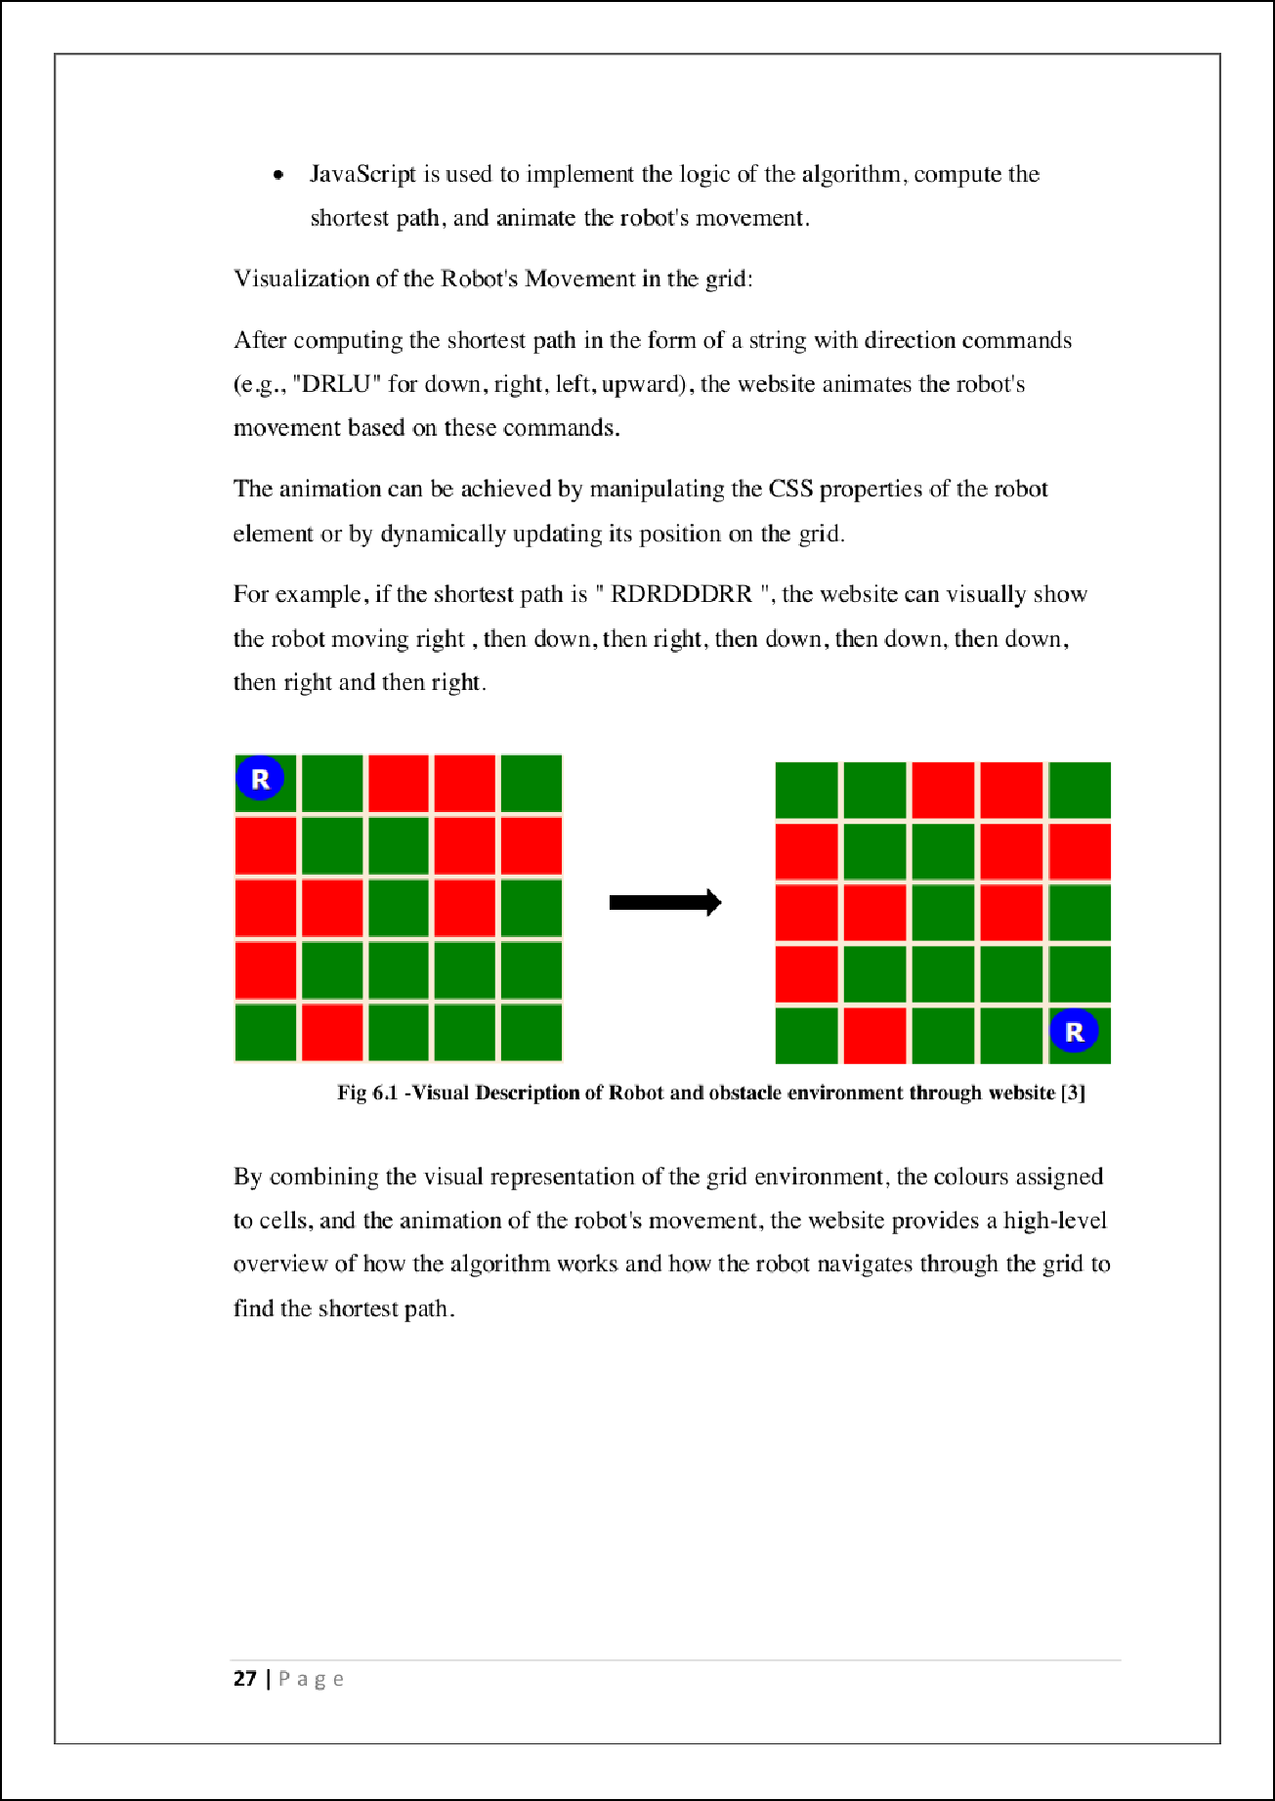

26

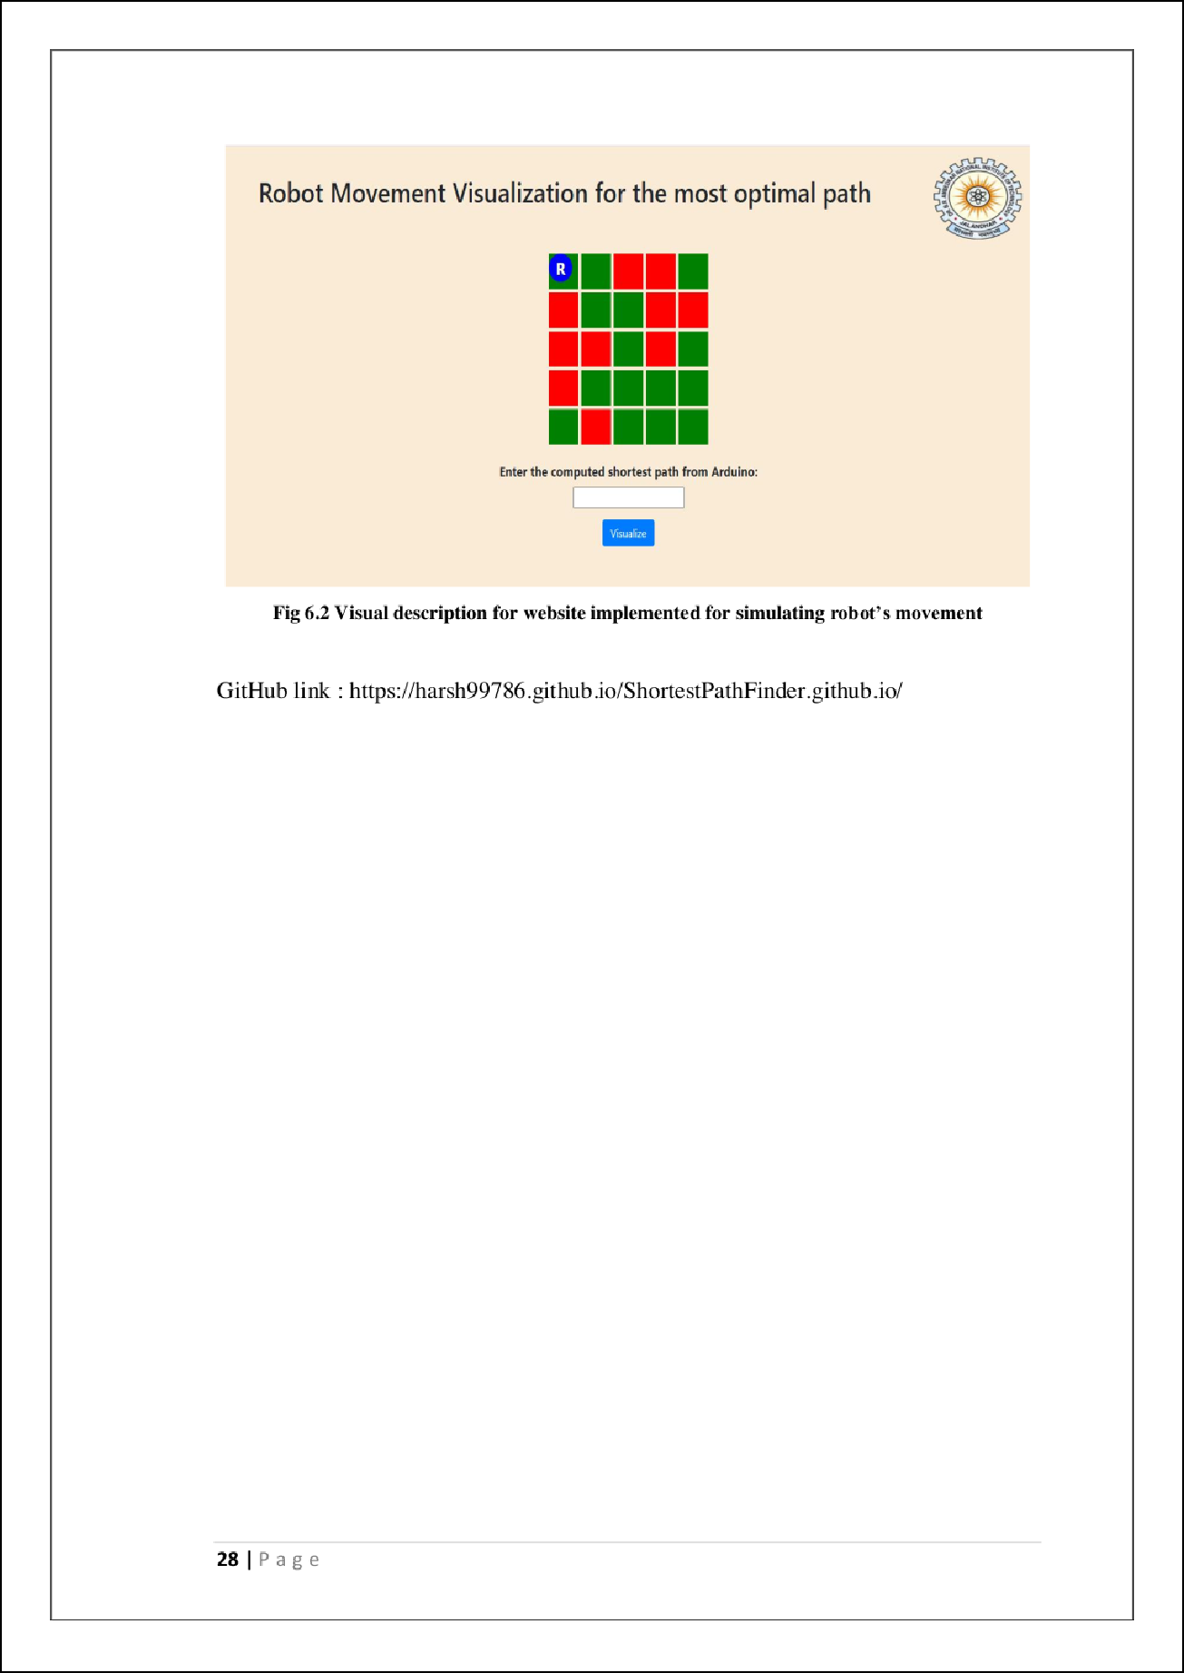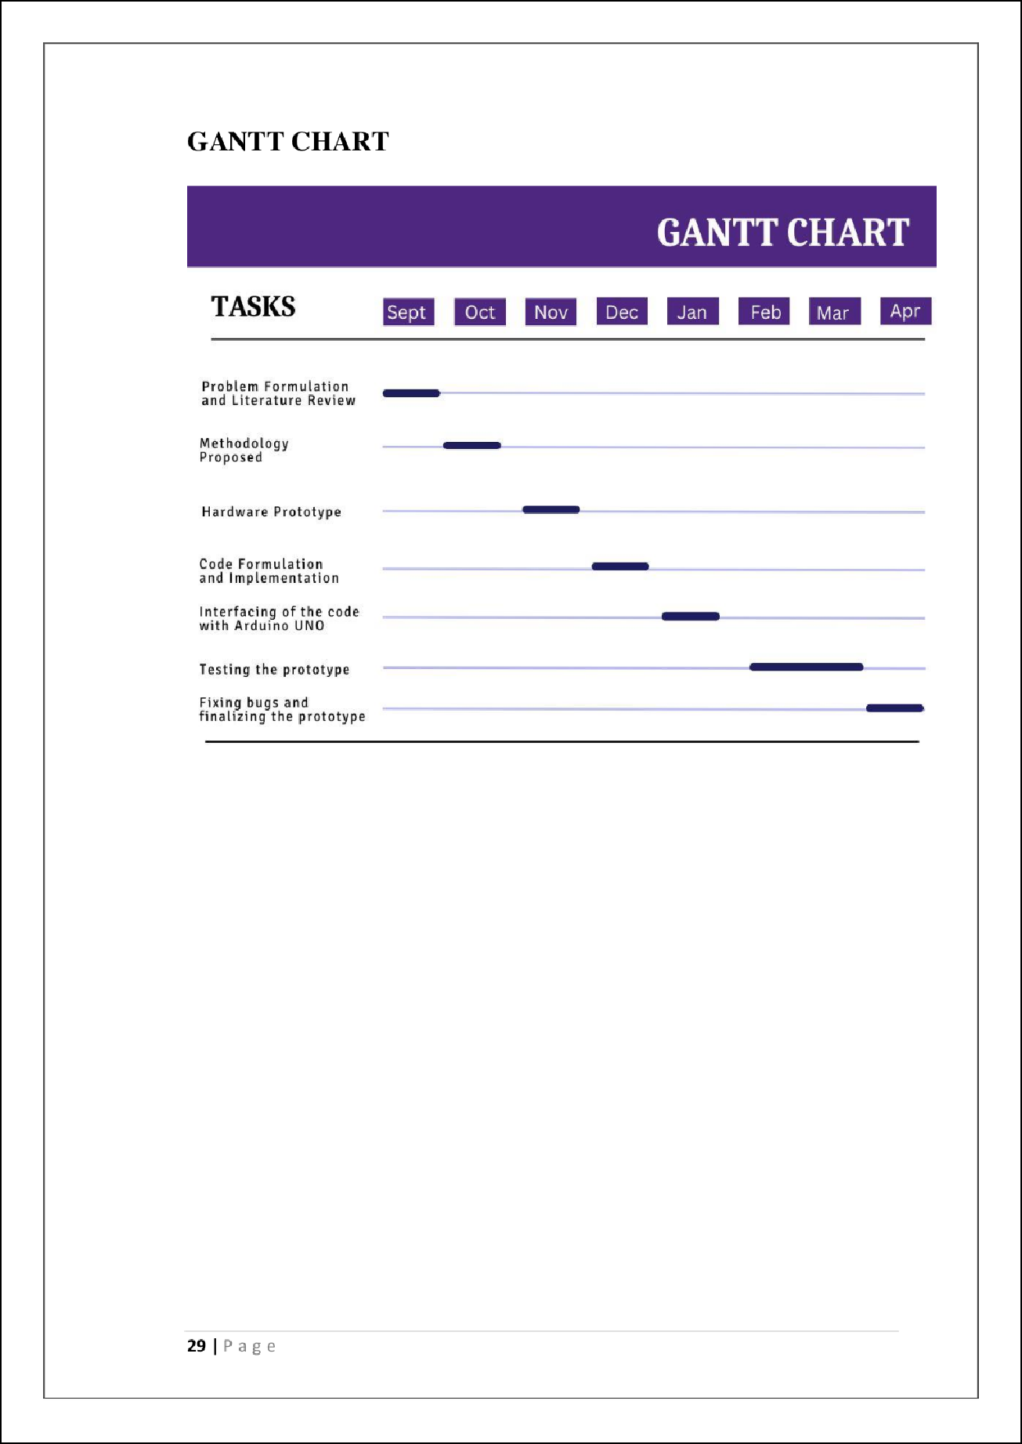

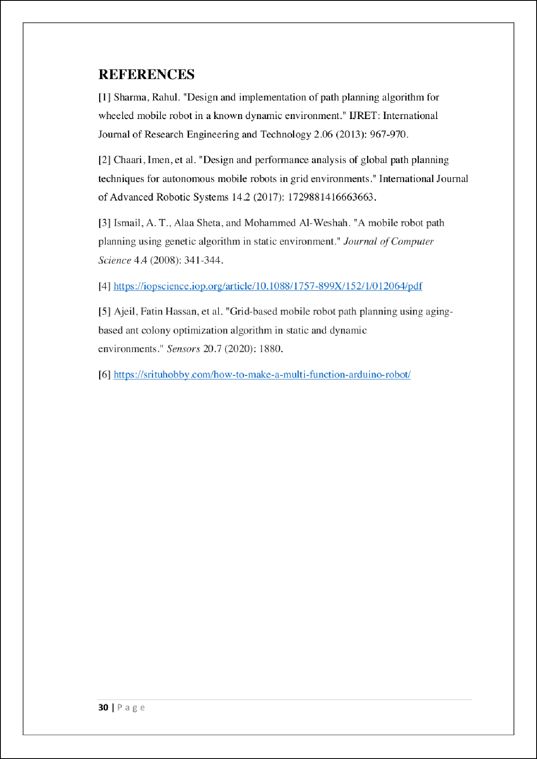

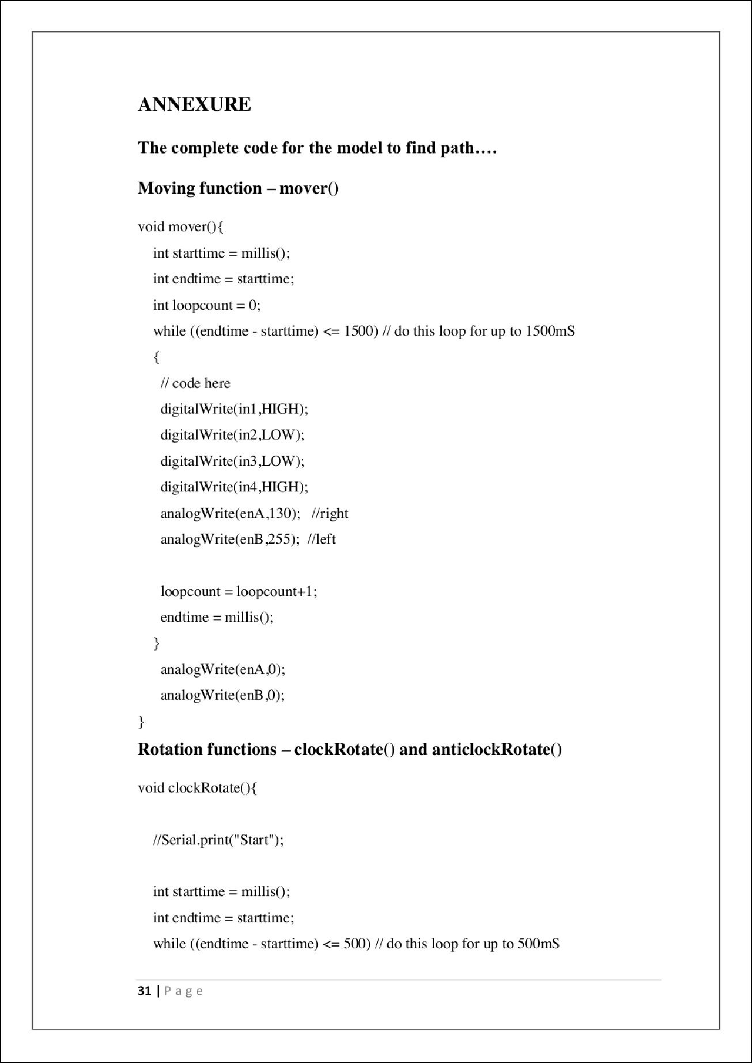

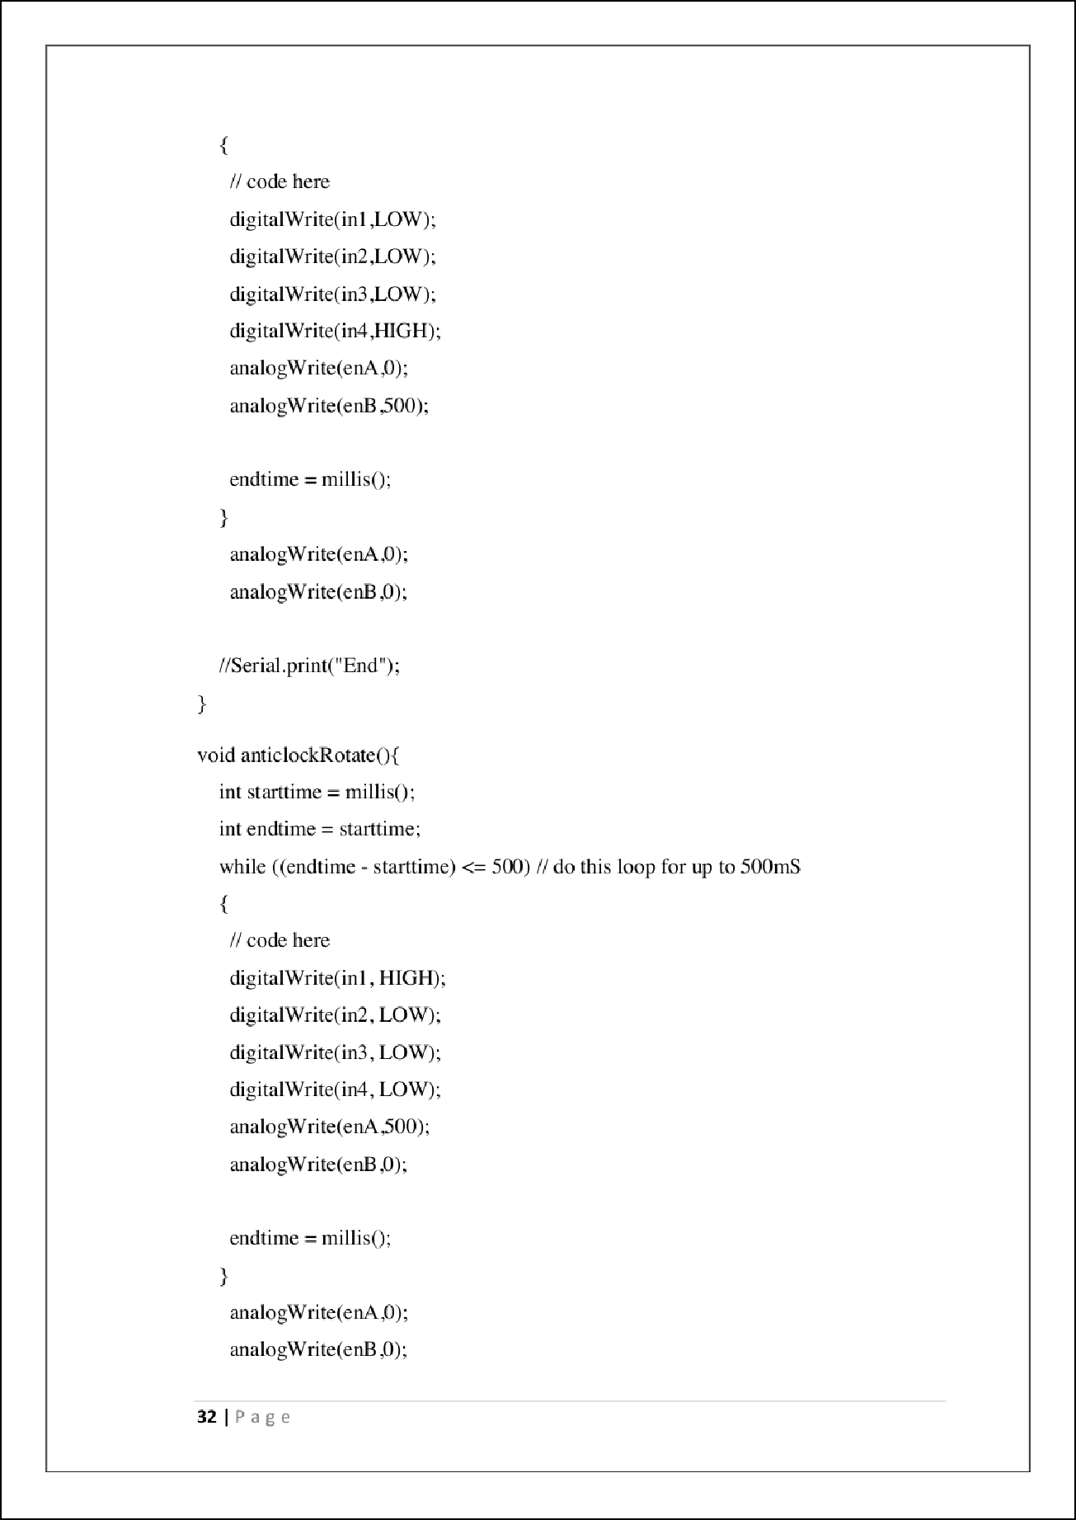

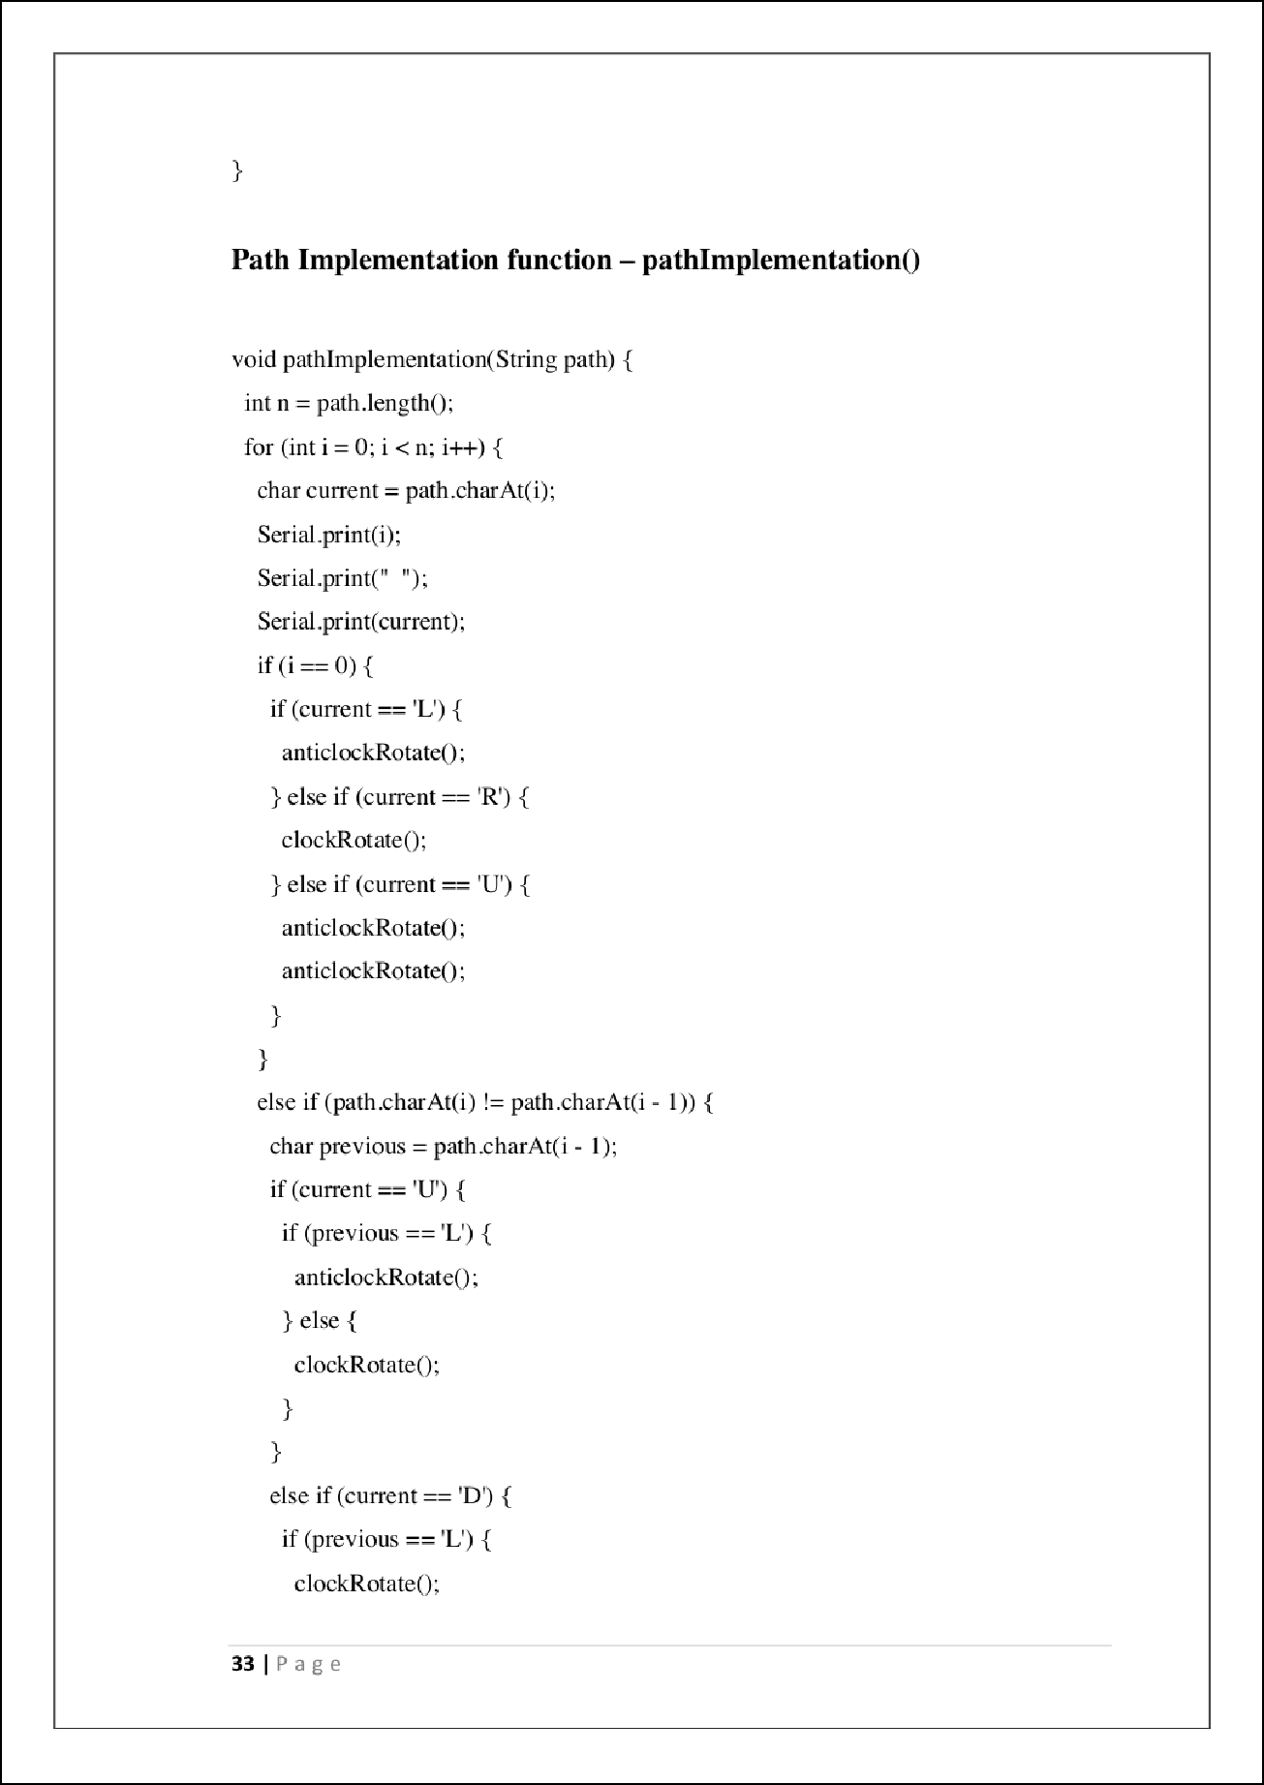

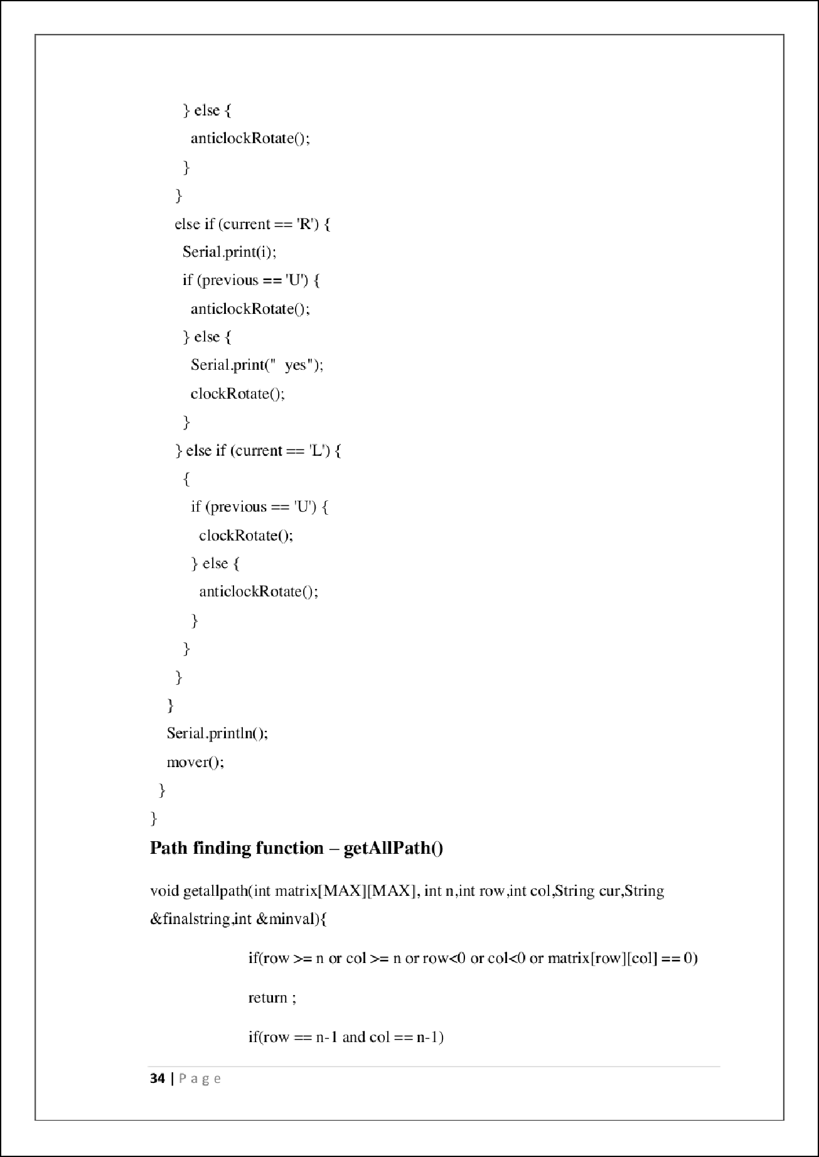

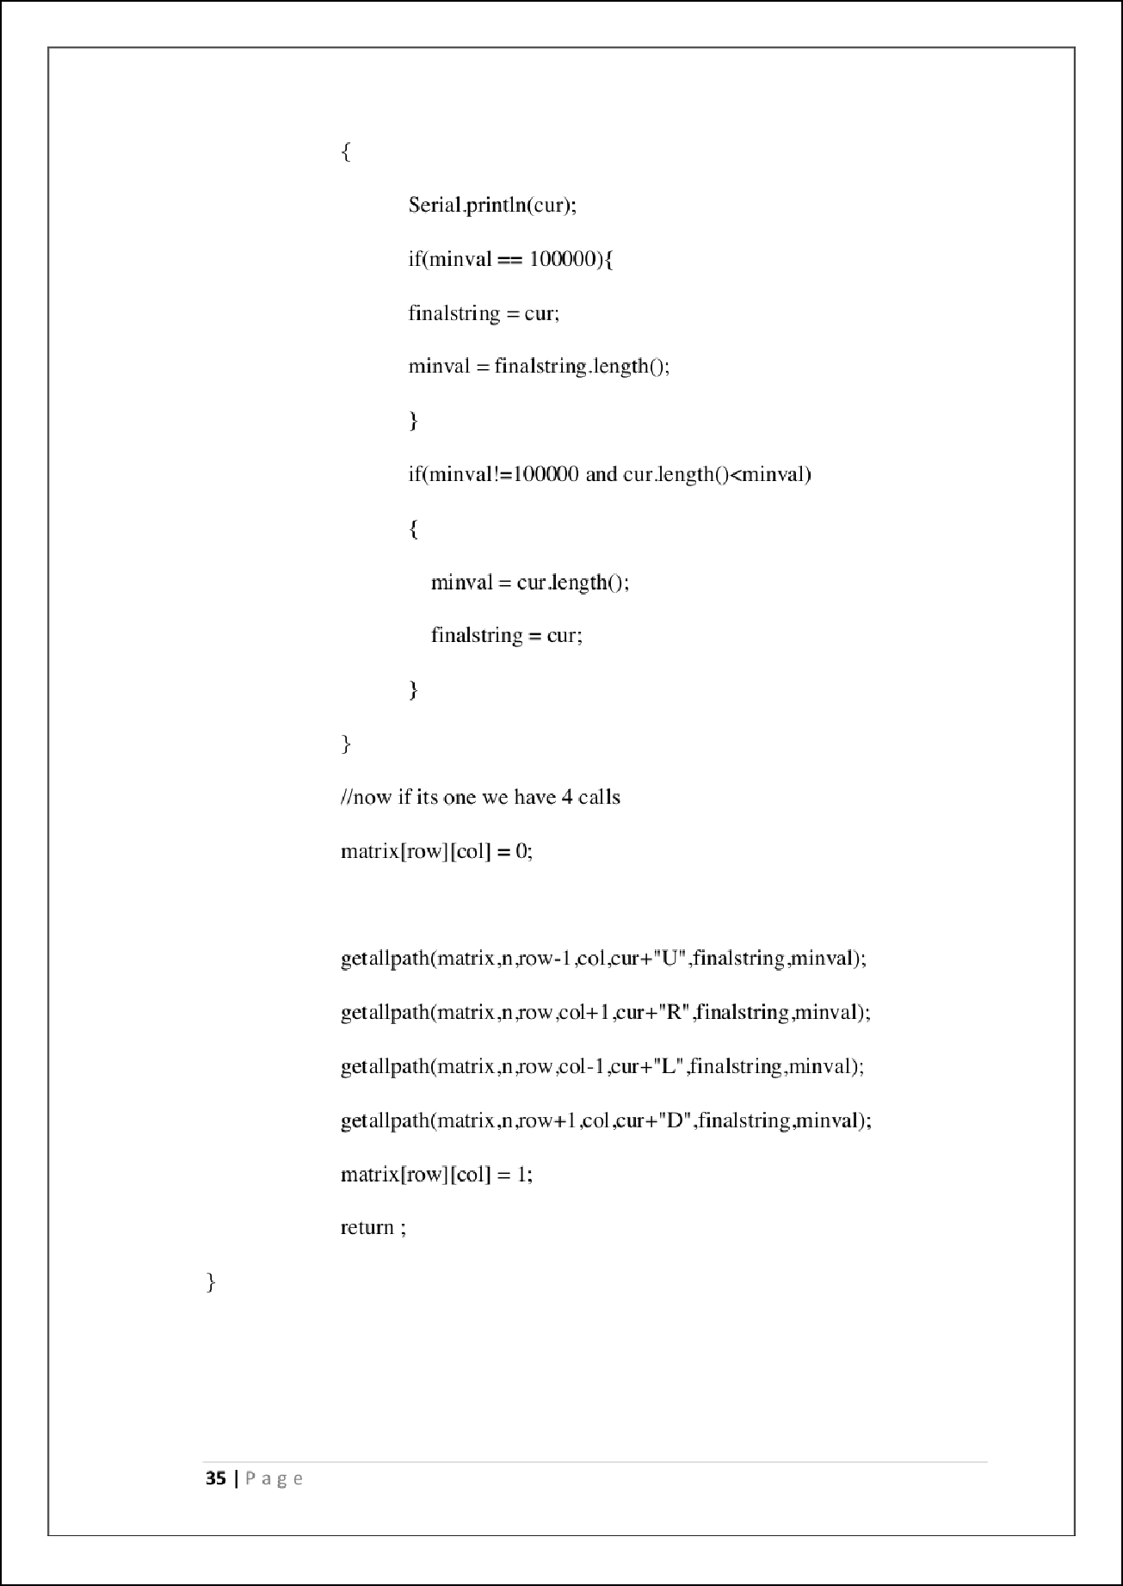

PLAG-After Literature Review Section

10

ORIGINALITY REPORT

%

SIMILARITY INDEX

7%

INTERNET SOURCES

7%

PUBLICATIONS

%

STUDENT PAPERS

PRIMARY SOURCES

[www.kscst.iisc.ernet.in](http://www.kscst.iisc.ernet.in/)

1

Internet Source

2 Biswanath Samanta. "Introduction to Mechatronics", Springer Science and Business Media LLC, 2023

Publication

archive.org

3

Internet Source

[www.electroniclinic.com](http://www.electroniclinic.com/)

4

Internet Source

[www.researchgate.net](http://www.researchgate.net/)

5

Internet Source

fr.slideshare.net

6

Internet Source

[www.slideshare.net](http://www.slideshare.net/)

7

Internet Source

8 Aman Manoj Dhadge. "Robot Imitating Human for Assistance and Companionship", Companion of the 2021 ACM/IEEE

1%

1%

1%

1%

1%

<1%

<1%

<1%

9

10

11

12

13

International Conference on Human-Robot Interaction, 2021

Publication

fdocuments.in

Internet Source

dronebotworkshop.com

Internet Source

T. Akilan, Ritesh Srivastava, M. Chandraprabha, Anuj Chaudhary, Aakarsh Garg, Aprateem Kumar Verma. "High Secure Wireless Video Surveillance Robot using IOT Technology", 2021 3rd International Conference on Advances in Computing, Communication Control and Networking (ICAC3N), 2021

Publication

Pedro Medeiros de Assis Brasil, Fabio Ugalde Pereira, Marco Antonio de Souza Leite Cuadros, Anselmo Rafael Cukla et al. "A Study on Global Path Planners Algorithms for the Simulated TurtleBot 3 Robot in ROS", 2020 Latin American Robotics Symposium (LARS), 2020 Brazilian Symposium on Robotics (SBR) and 2020 Workshop on Robotics in Education (WRE), 2020

Publication

[www.mdpi.com](http://www.mdpi.com/)

Internet Source

<1%

<1%

<1%

<1%

<1%

14

15

16

17

18

19

20

21

22

dory.cauccimarble.it

Internet Source

ethesis.nitrkl.ac.in

Internet Source

marketbusinessnews.com

Internet Source

Faruk Civan. "Field diagnosis and measurement of formation damage", Elsevier BV, 2023

Publication

[www.ijnrd.org](http://www.ijnrd.org/)

Internet Source

Davoodi, Mansoor, Fatemeh Panahi, Ali Mohades, and Seyed Naser Hashemi. "Multi- objective path planning in discrete space", Applied Soft Computing, 2013.

Publication

Zaiyan Khan, Rishikesh Varvade, Jinan Fiaidhi. "Smart Shoes For Visually Impaired", Institute of Electrical and Electronics Engineers (IEEE), 2020

Publication

hozz-lassam.com

Internet Source

[www.openworldlearning.org](http://www.openworldlearning.org/)

Internet Source

<1%

<1%

<1%

<1%

<1%

<1%

<1%

<1%

<1%

23

24

25

26

27

28

29

30

ifpy.tuttomotosrl.it

Internet Source

[www.gub.uy](http://www.gub.uy/)

Internet Source

"Towards Autonomous Robotic Systems", Springer Science and Business Media LLC, 2018

Publication

Xiaohong Li, Maolin Li. "The Direction Analysis on Trajectory of Fast Neural Network Learning Robot", IEEE Access, 2021

Publication

francis-press.com

Internet Source

sites.google.com

Internet Source

[www.ijert.org](http://www.ijert.org/)

Internet Source

Faizal Arya Samman, Tajuddin Waris, Tiara Dwi Anugerah, Muhammad Nuralim Zain Mide. "Three-phase inverter using microcontroller for speed control application on induction motor", 2014 Makassar International Conference on Electrical Engineering and Informatics (MICEEI), 2014

Publication

<1%

<1%

<1%

<1%

<1%

<1%

<1%

<1%

Exclude quotes Oﬀ Exclude bibliography On

Exclude matches Oﬀ